CCE AV Guide

*Tip - Hold the CTRL button on your keyboard and Click on the section you want to go to.

Table of Contents

Napa Hall 2

Napa Hall Podium 2

Napa Hall Podium Connections 3

Handheld Microphone 4

Lapel Microphone 5

Document Cam 6

Powering on the projector 7

Connecting your Laptop to the projector via HDMI 7

Connecting your Laptop to the projector via VGA and Audio Cable 9

Connecting your Laptop to the projector via USB-C to VGA adapter 12

Connecting your Laptop to ShareLink using the ShareLink Pro App 15

Connecting your Laptop to ShareLink through the web browser 21

Connecting your iPhone/iPad to ShareLink using the Mobile App 28

Using the Podiums built in computer 36

Using the Handheld Microphone 39

Using the Lapel Microphone 40

Using the Document Camera 42

Powering off the projector 45

Modoc Hall 47

Modoc Hall Podium 47

Modoc Hall Podium Connections 48

Powering on the projector 48

Connecting your Laptop to the projector via HDMI 49

Connecting your Laptop to the projector via VGA and Audio Cable 52

Connecting your Laptop to the projector via USB-C to VGA adapter 54

Connecting your Laptop to ShareLink using the ShareLink App 57

Handheld Microphone   63

Lapel Microphone  65

# Napa Hall

## Napa Hall Podium

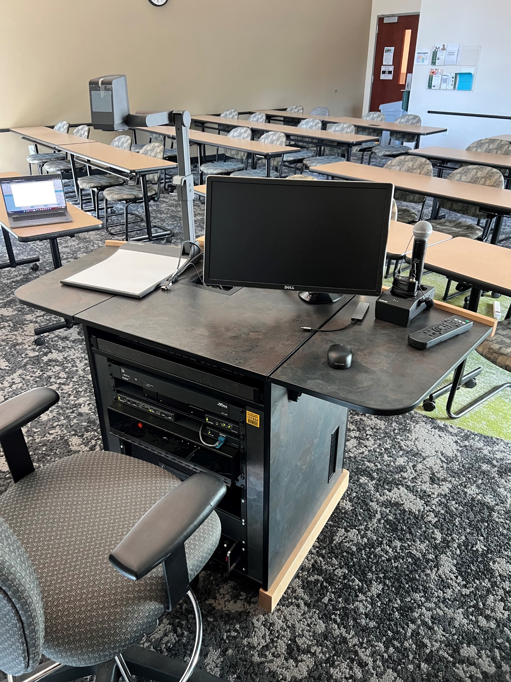

## Napa Hall Podium Connections

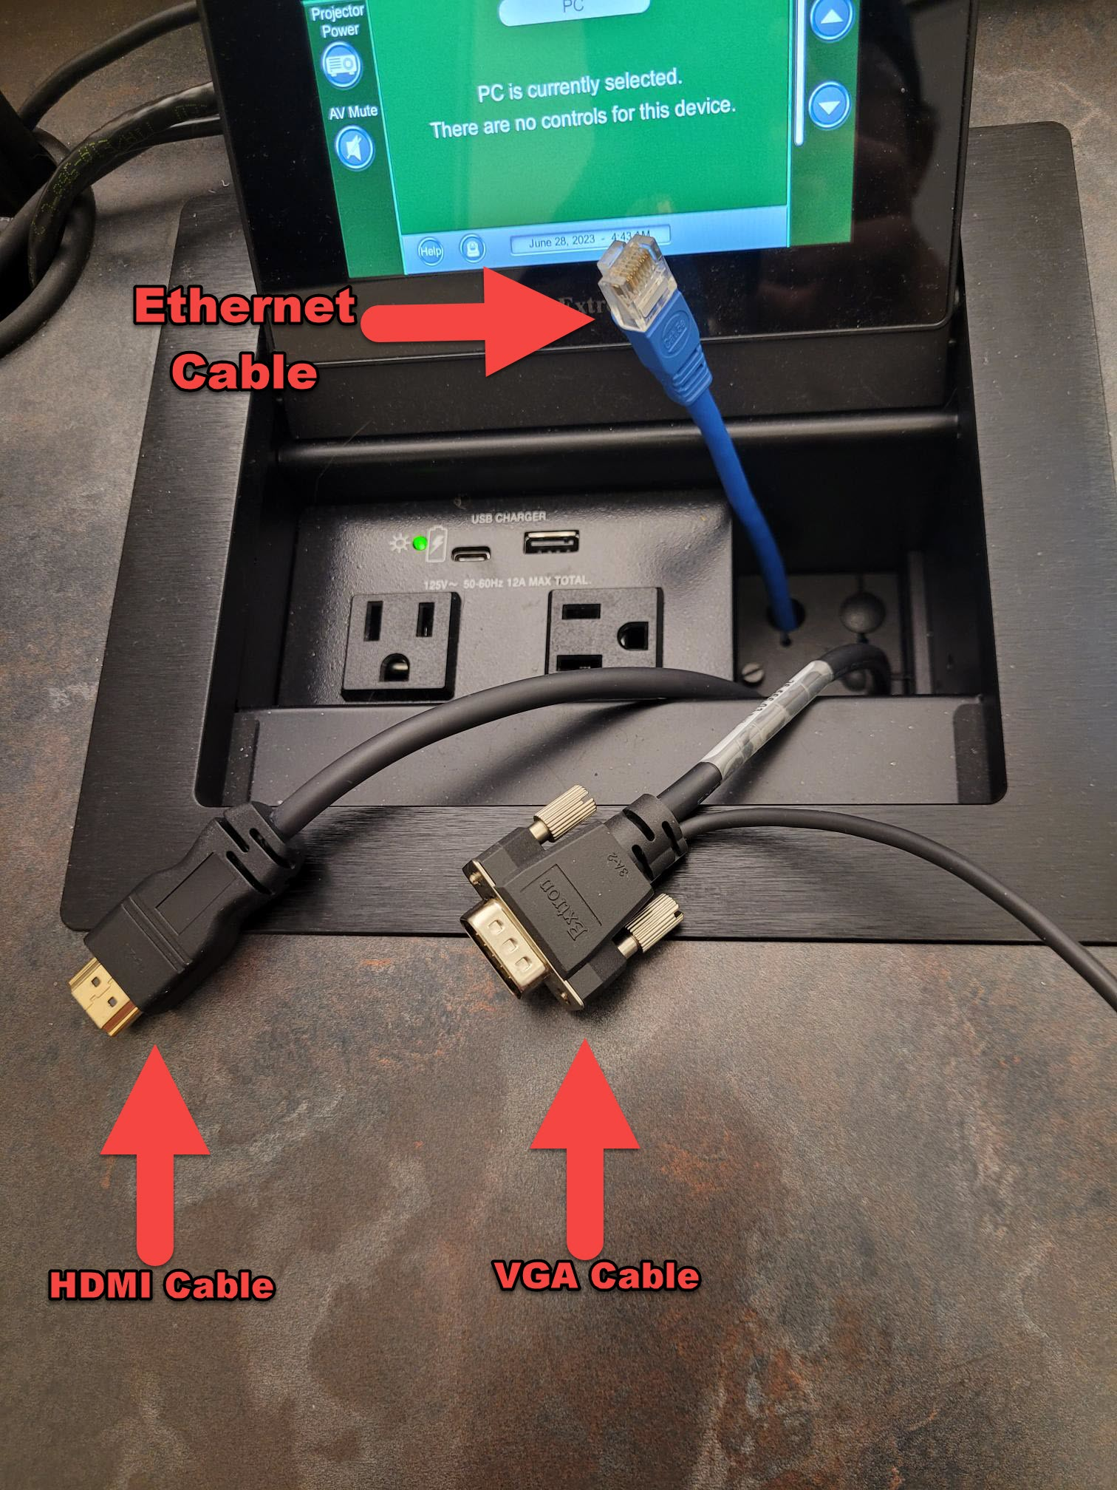

## Handheld Microphone

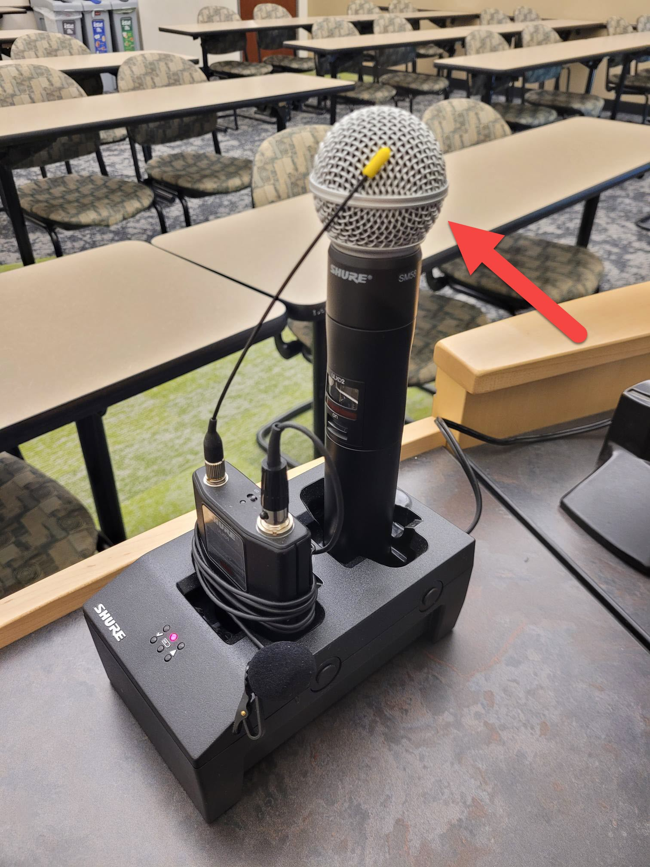

## Lapel Microphone

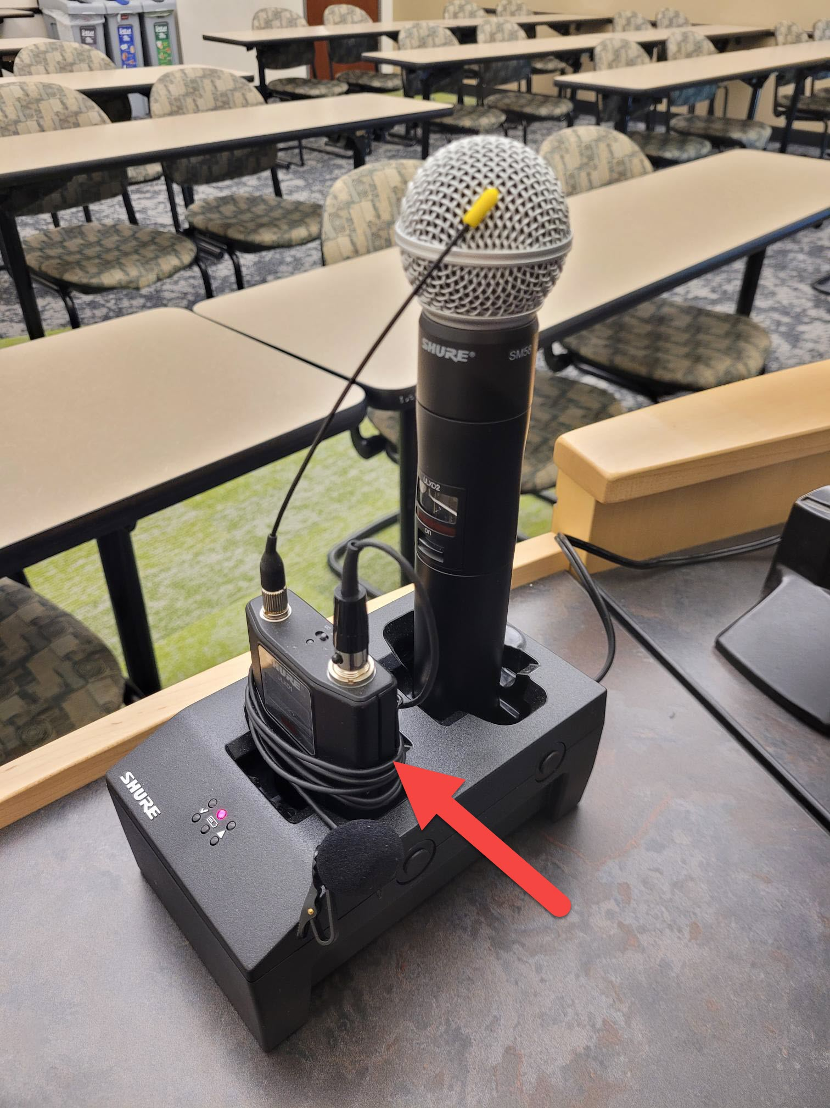

## Document Cam

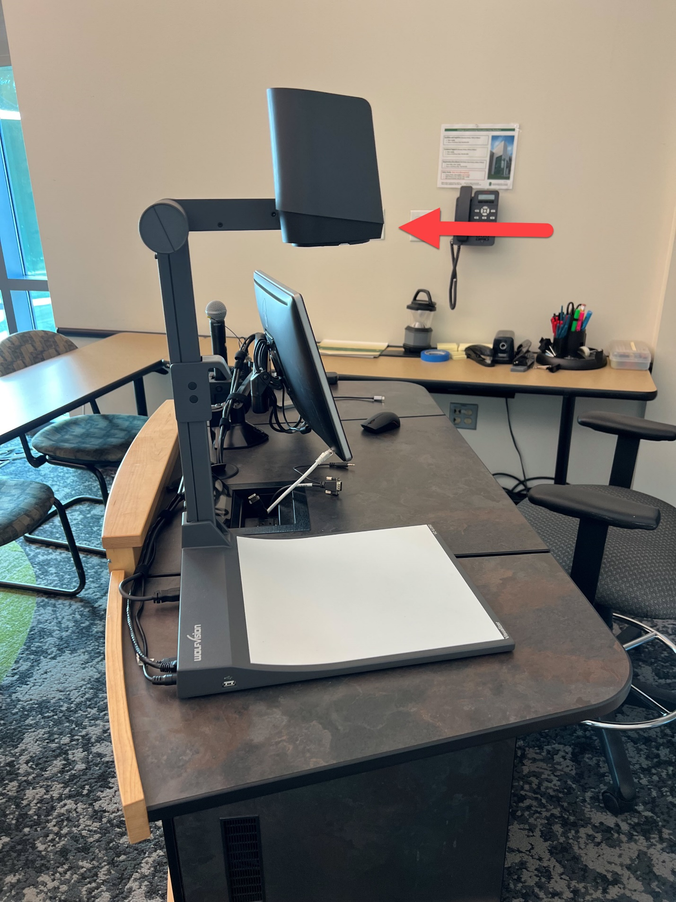

## Powering on the projector

* + If the touch screen is blank, tap anywhere on the screen to wake it up.
  + Tap the Projector Power icon to turn on the projector.

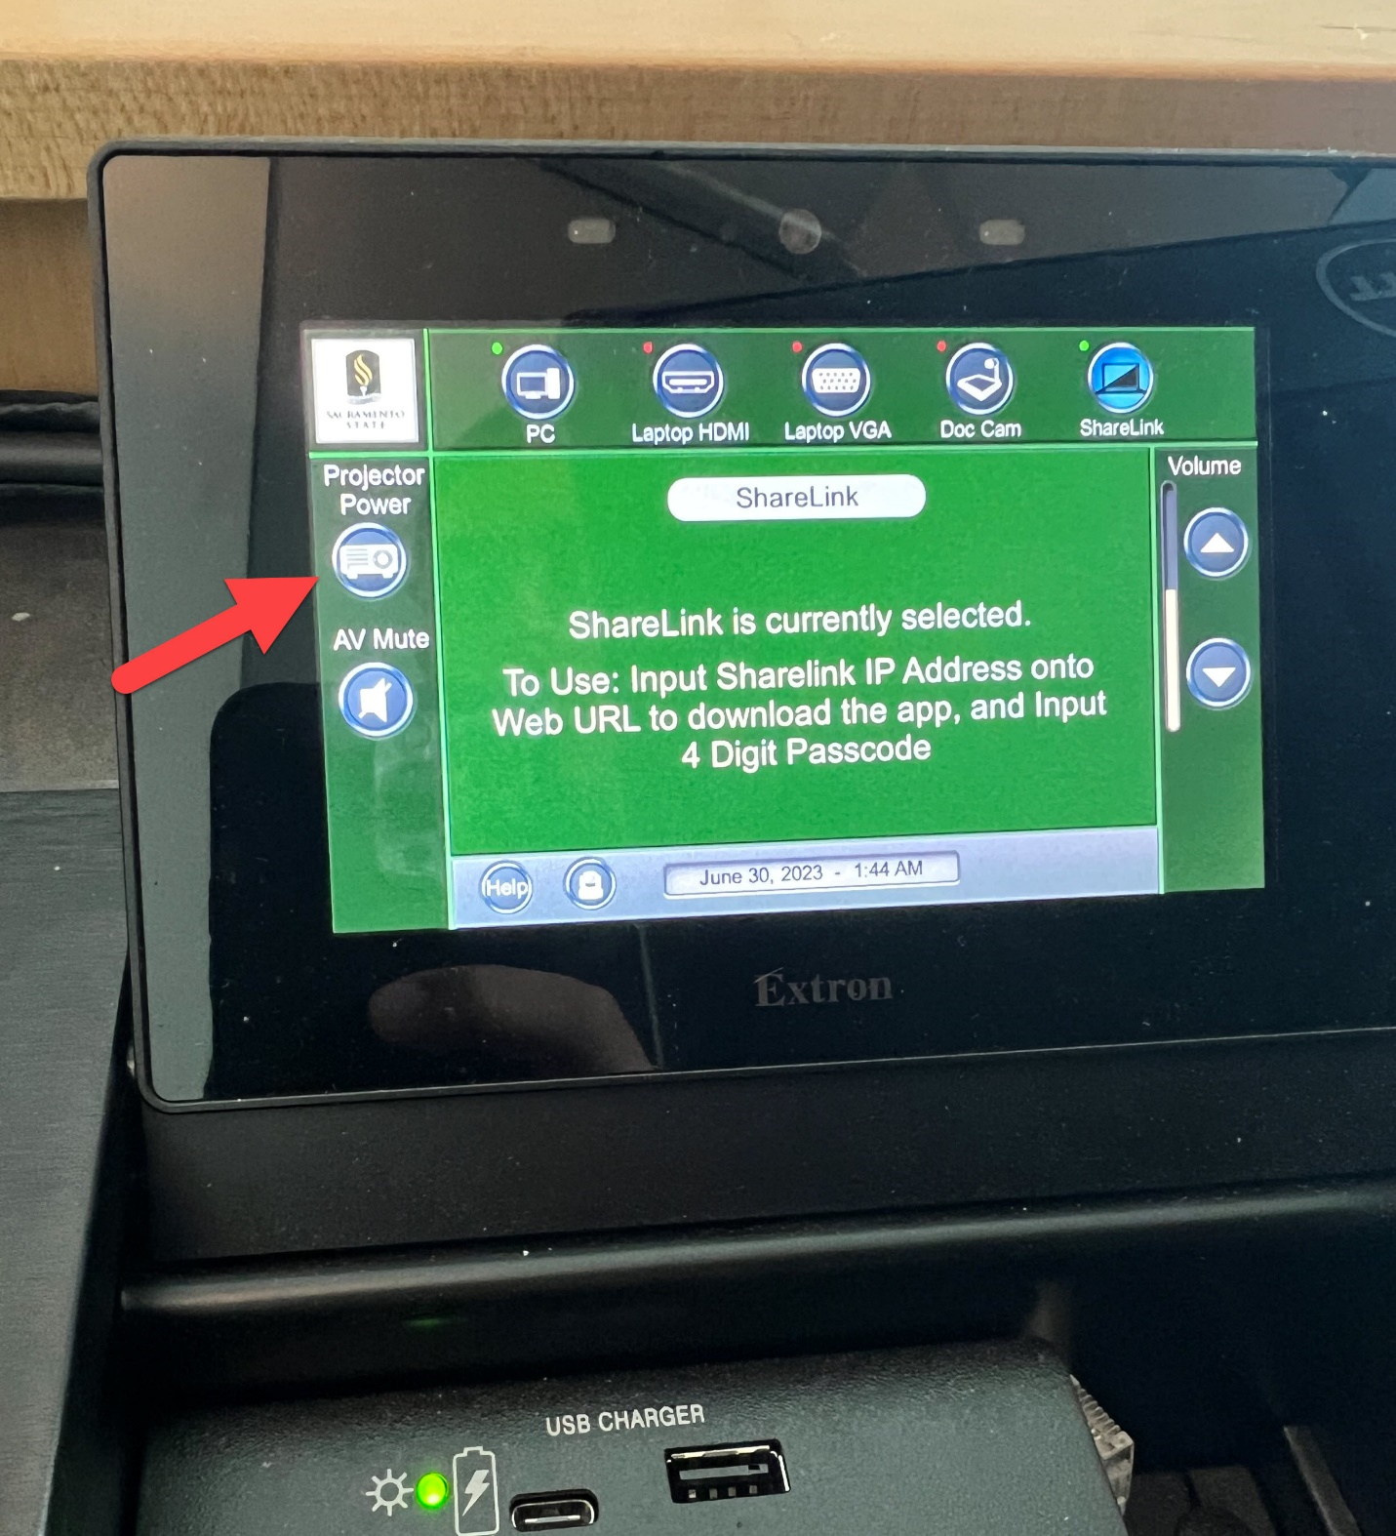

## Connecting your Laptop to the projector via HDMI

* + Connect the podiums HDMI cable into the HDMI port on your computer.

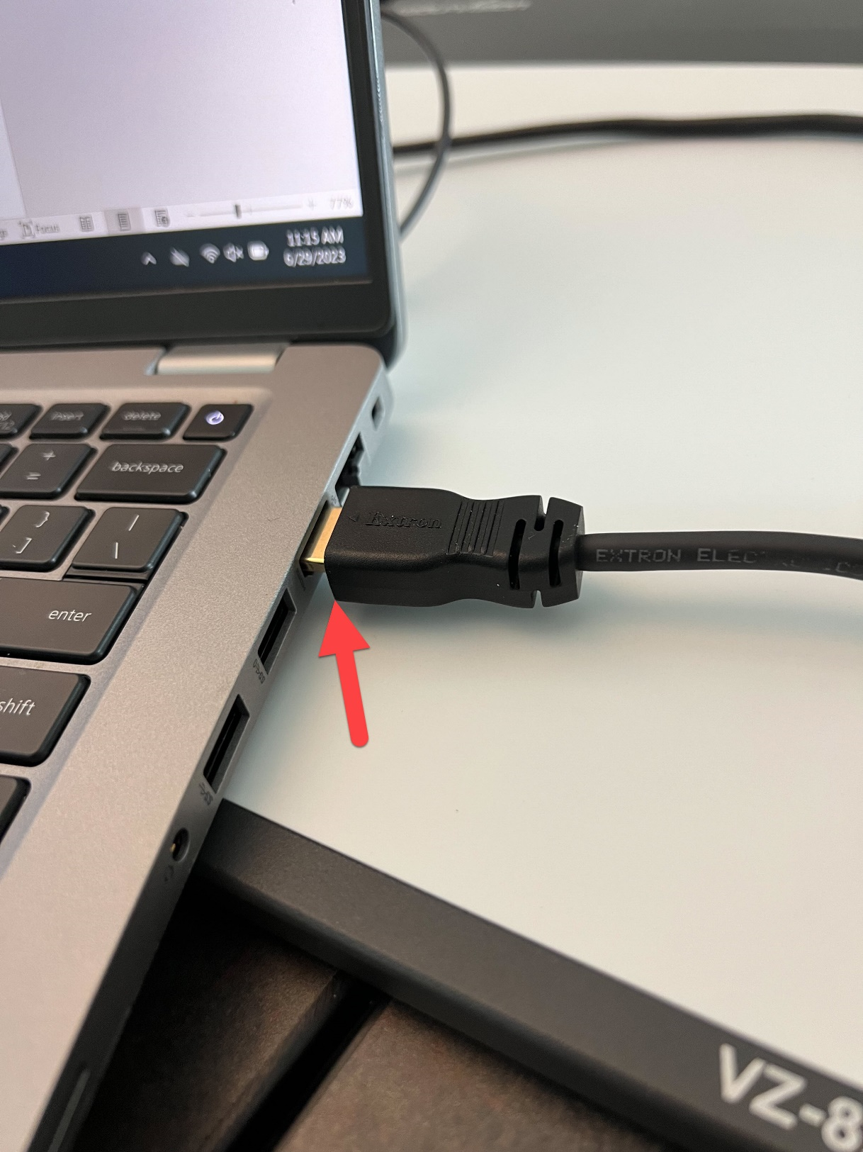

* + Switch the source on the touchscreen to HDMI by tapping Laptop HDMI.

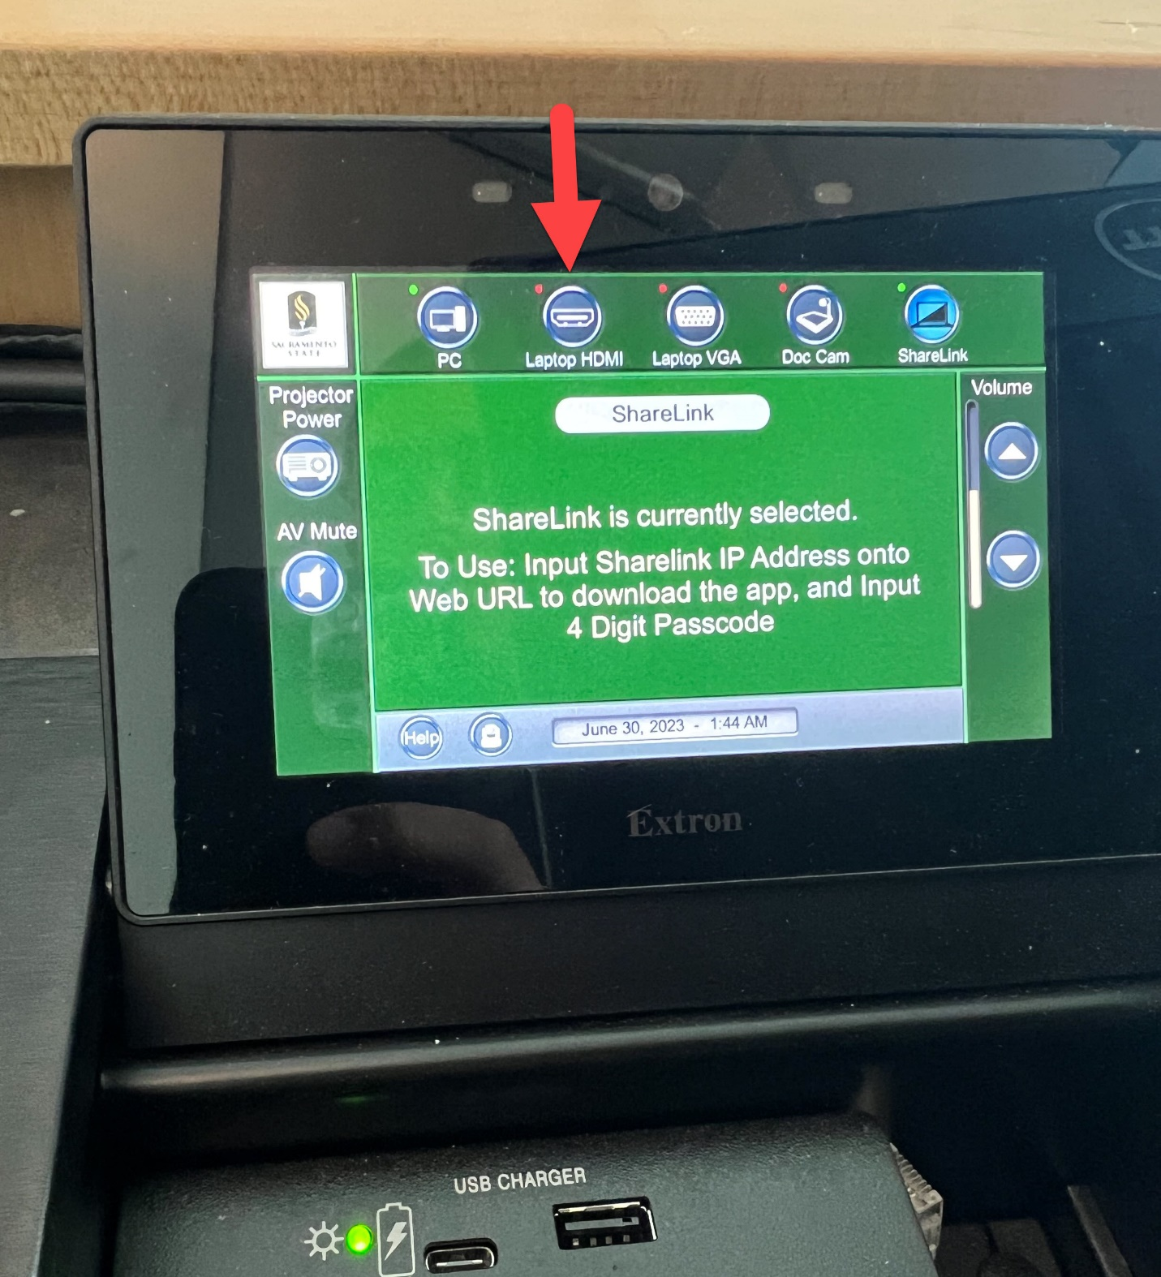

## Connecting your Laptop to the projector via VGA and Audio Cable

* + Connect the podiums VGA cable to the VGA port on your computer.
  + Connect the podiums Audio cable to the audio port on your computer.

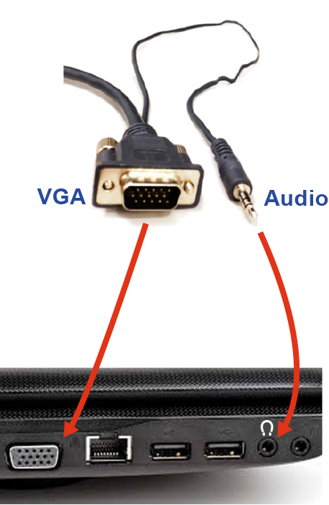

* + Switch the source on the touchscreen to VGA by tapping Laptop VGA.

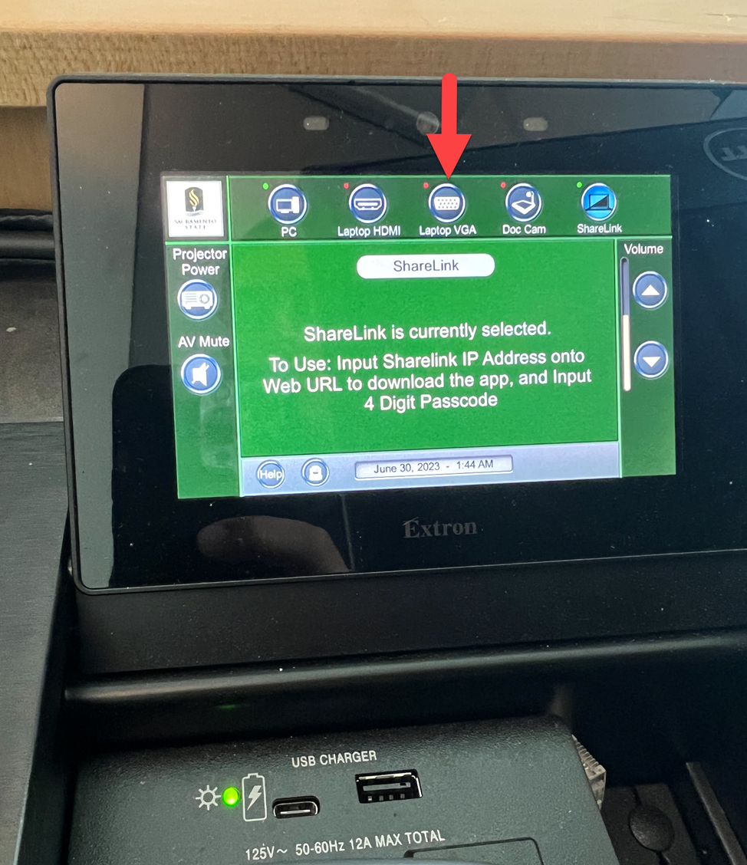

## Connecting your Laptop to the projector via USB-C to VGA adapter

* + Connect the USB-C adapter to a USB-C port on your computer.

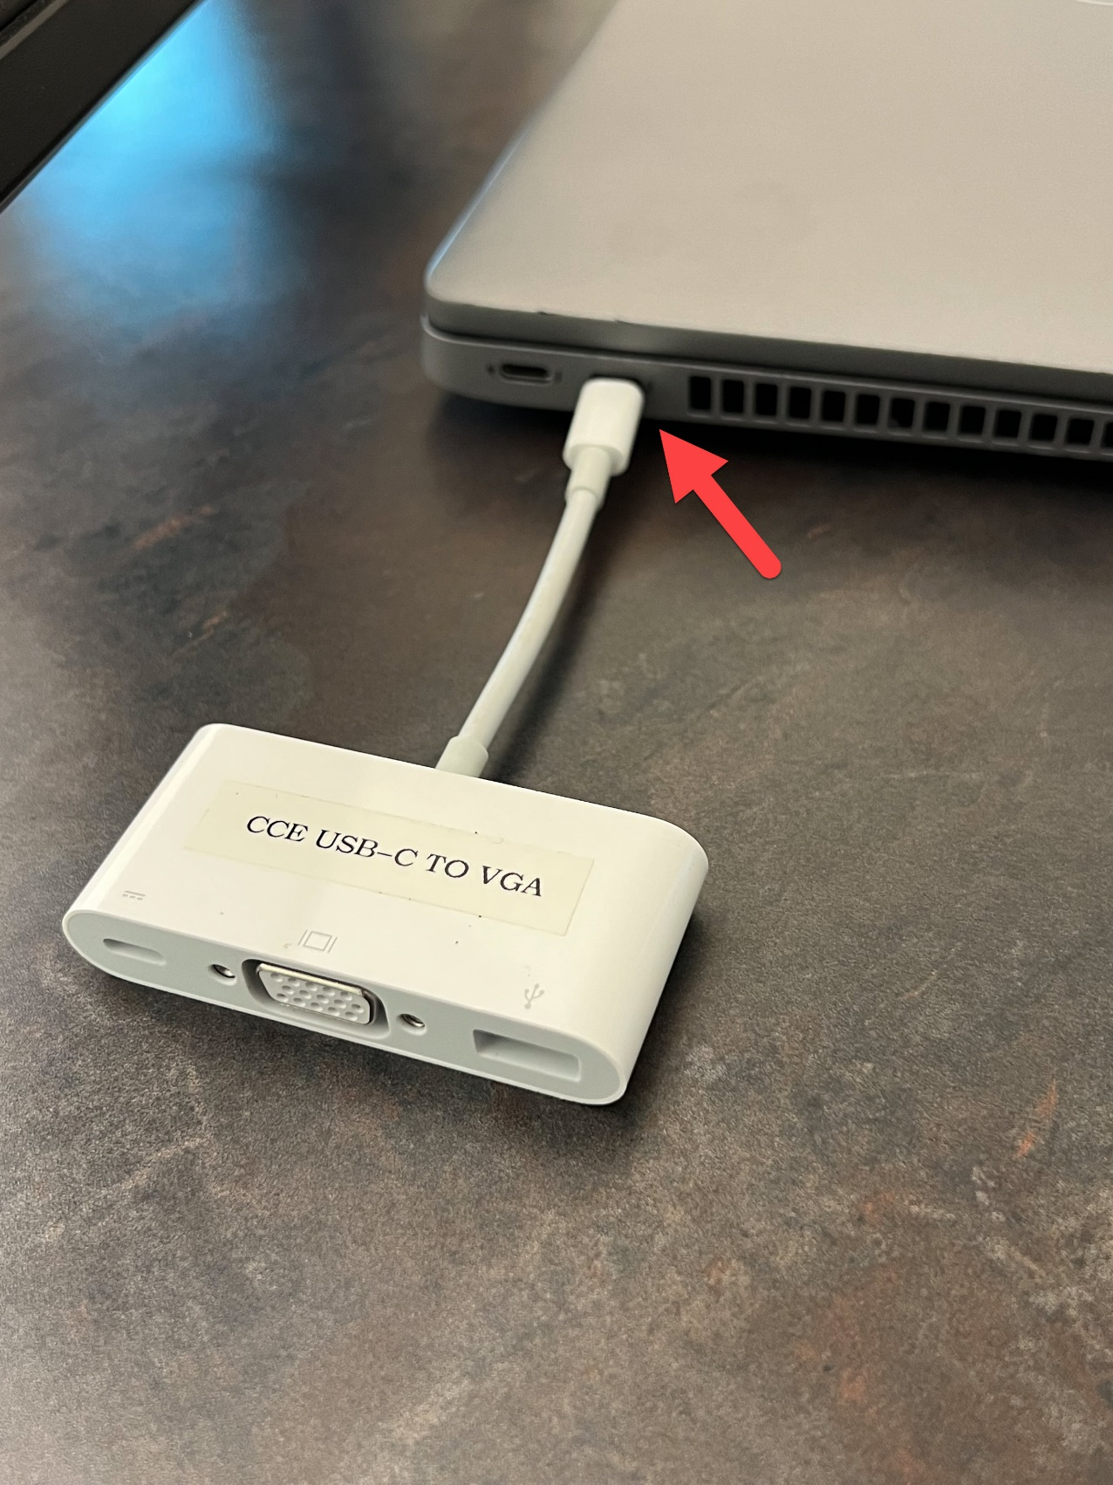

* + Connect the VGA cable to the USB-C adapter.

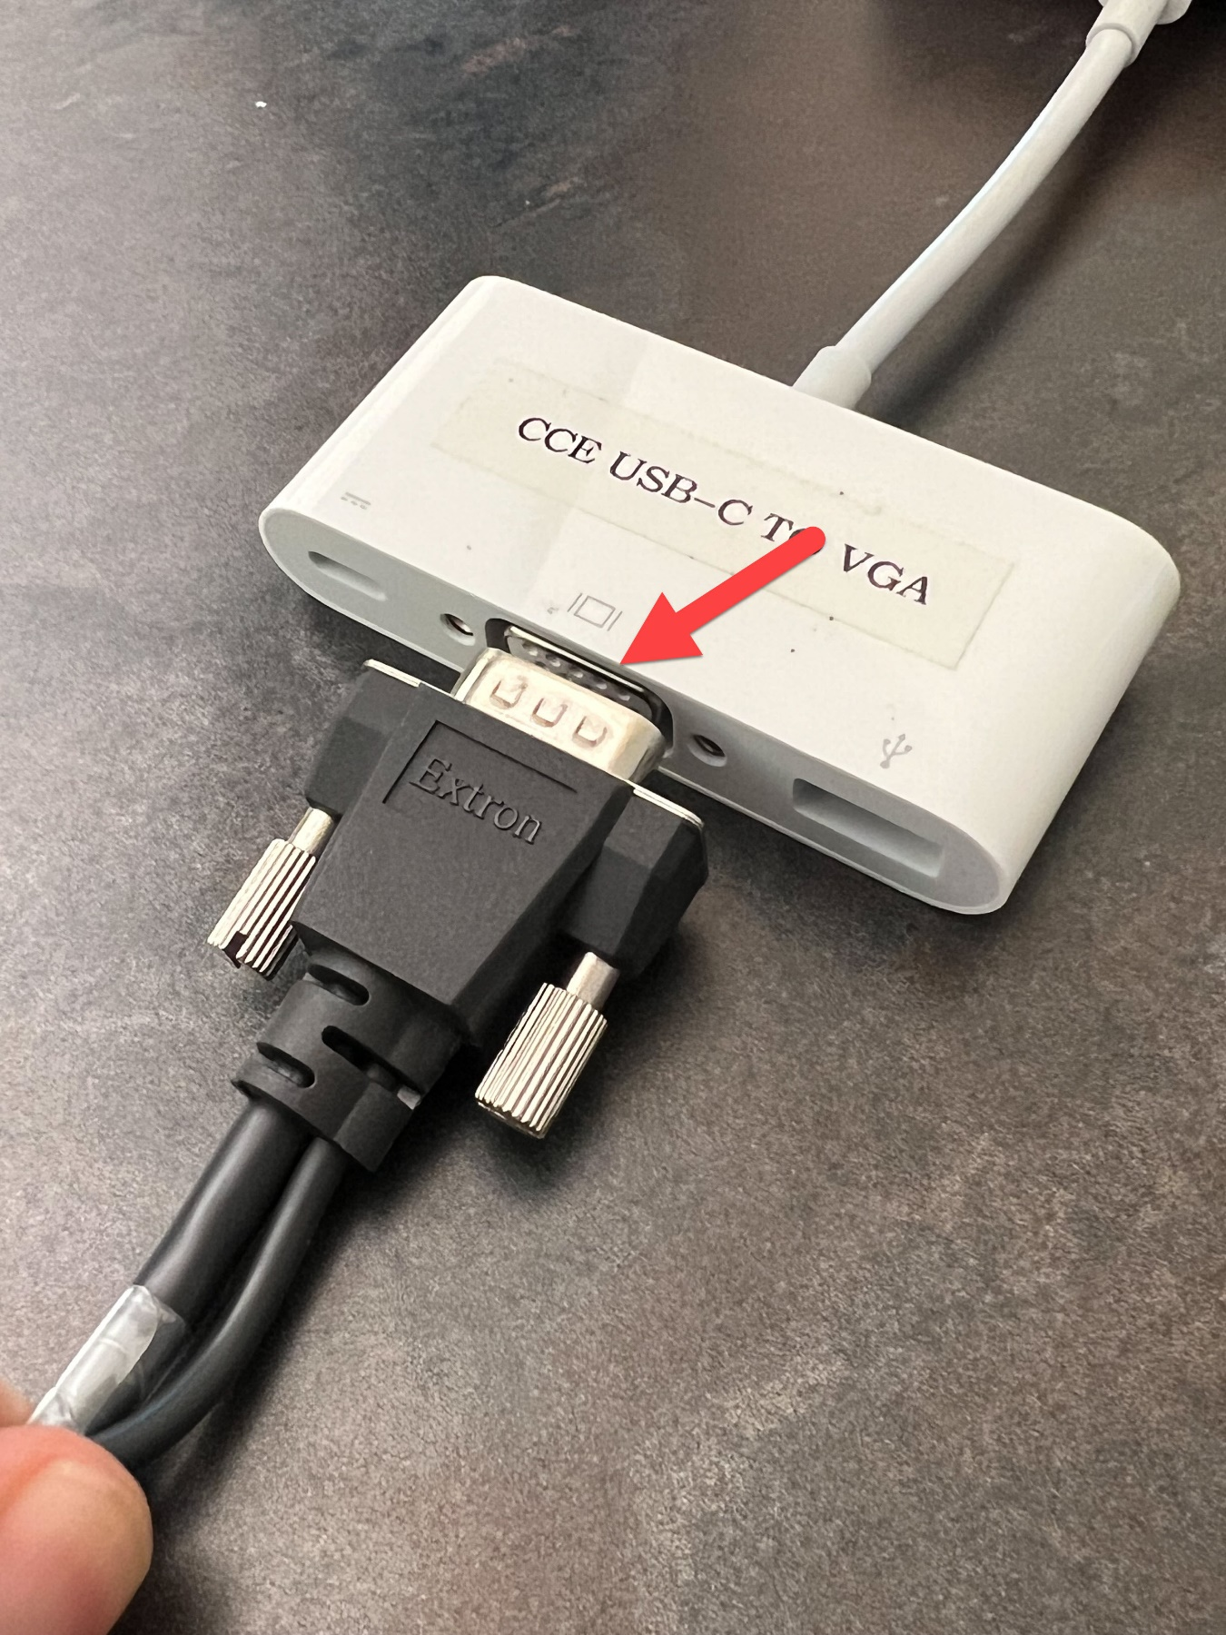

* + Switch the source on the touchscreen to VGA by tapping Laptop VGA.



## Connecting your Laptop to ShareLink using the ShareLink Pro App

* + Switch the source on the touchscreen to ShareLink by tapping on ShareLink.

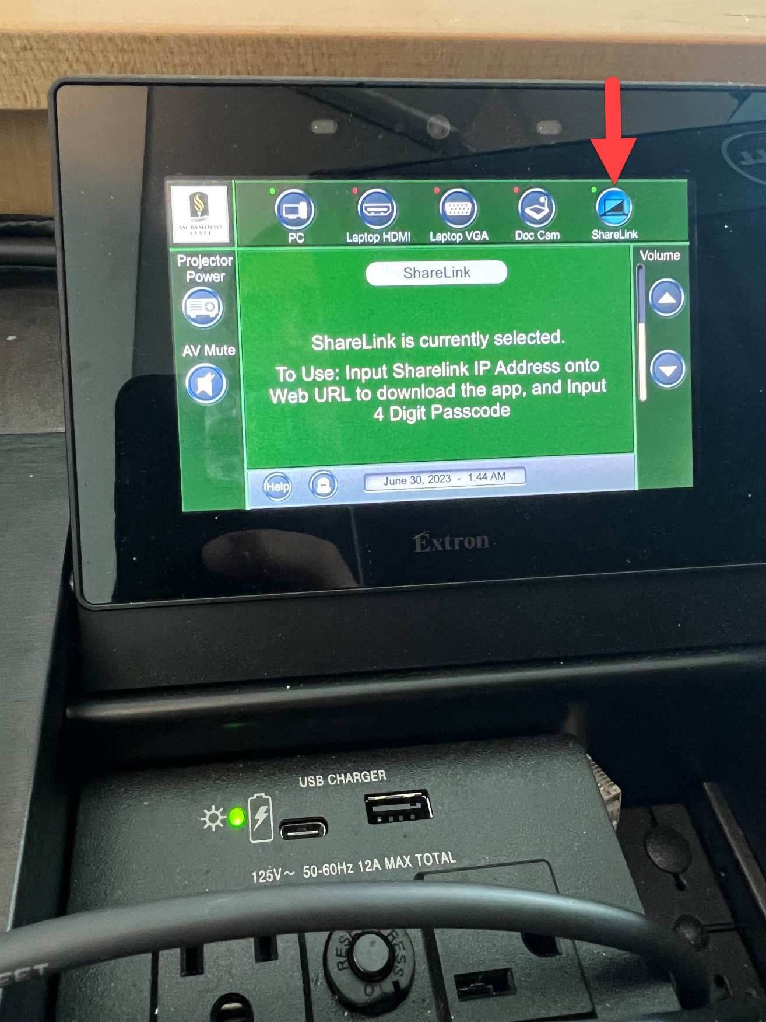

You will see this screen on the projector and or monitor.

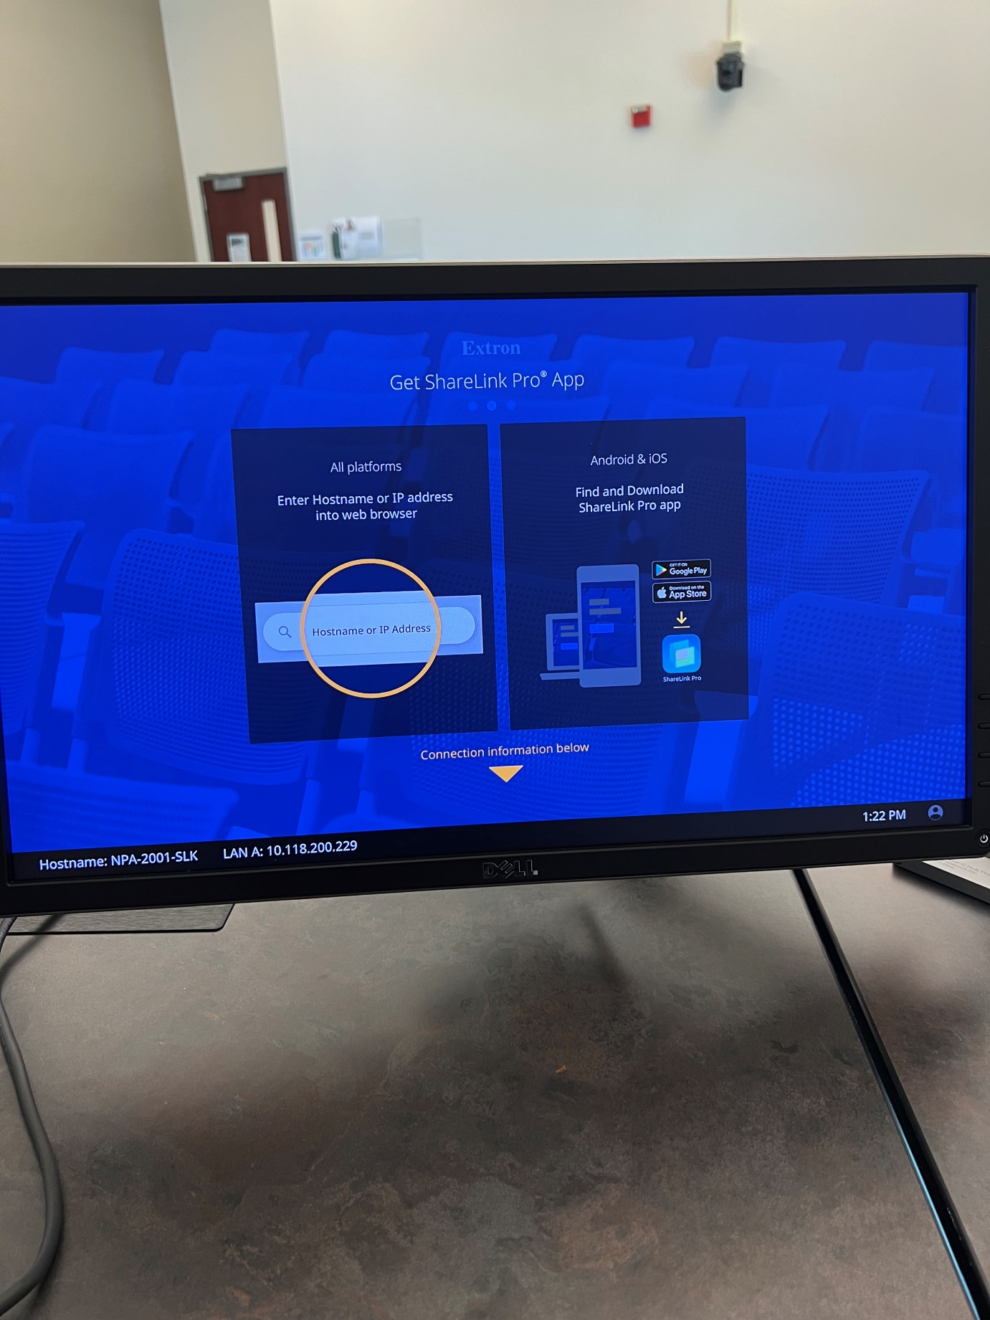

* + At the bottom of the screen, you will see your devices IP address.

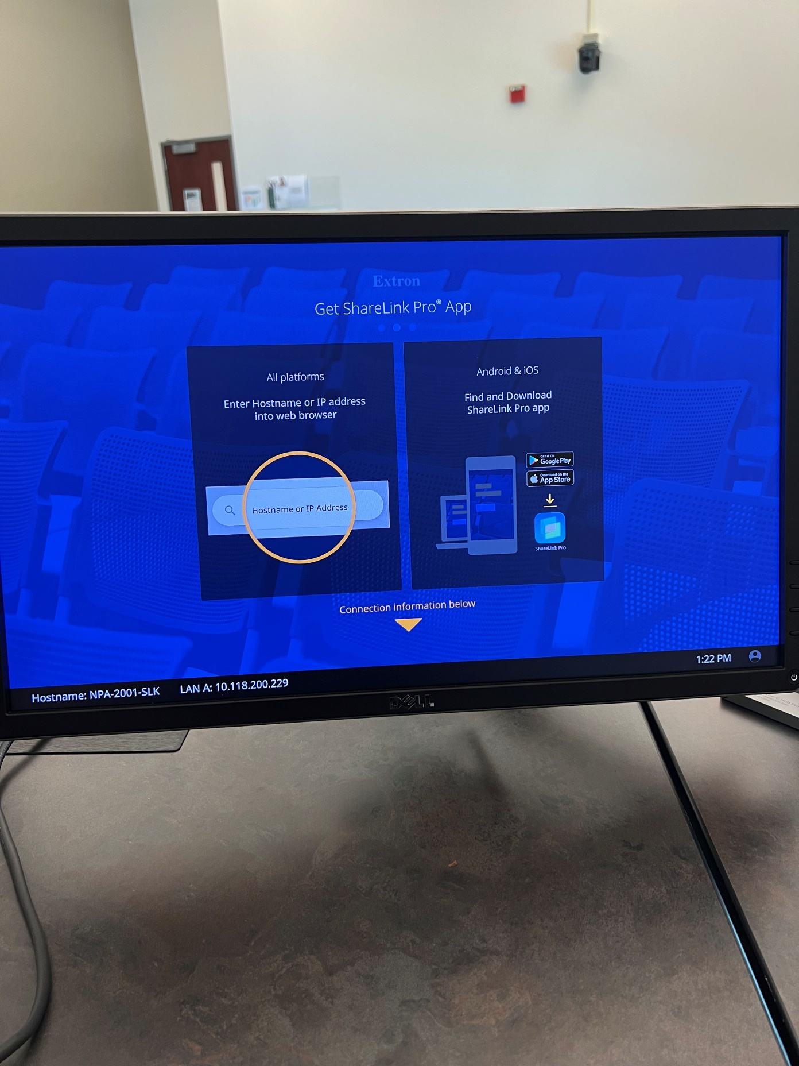

* + Open the ShareLink Pro app on your computer. You will be greeted with this screen.
  + Click the plus sign to add your device.

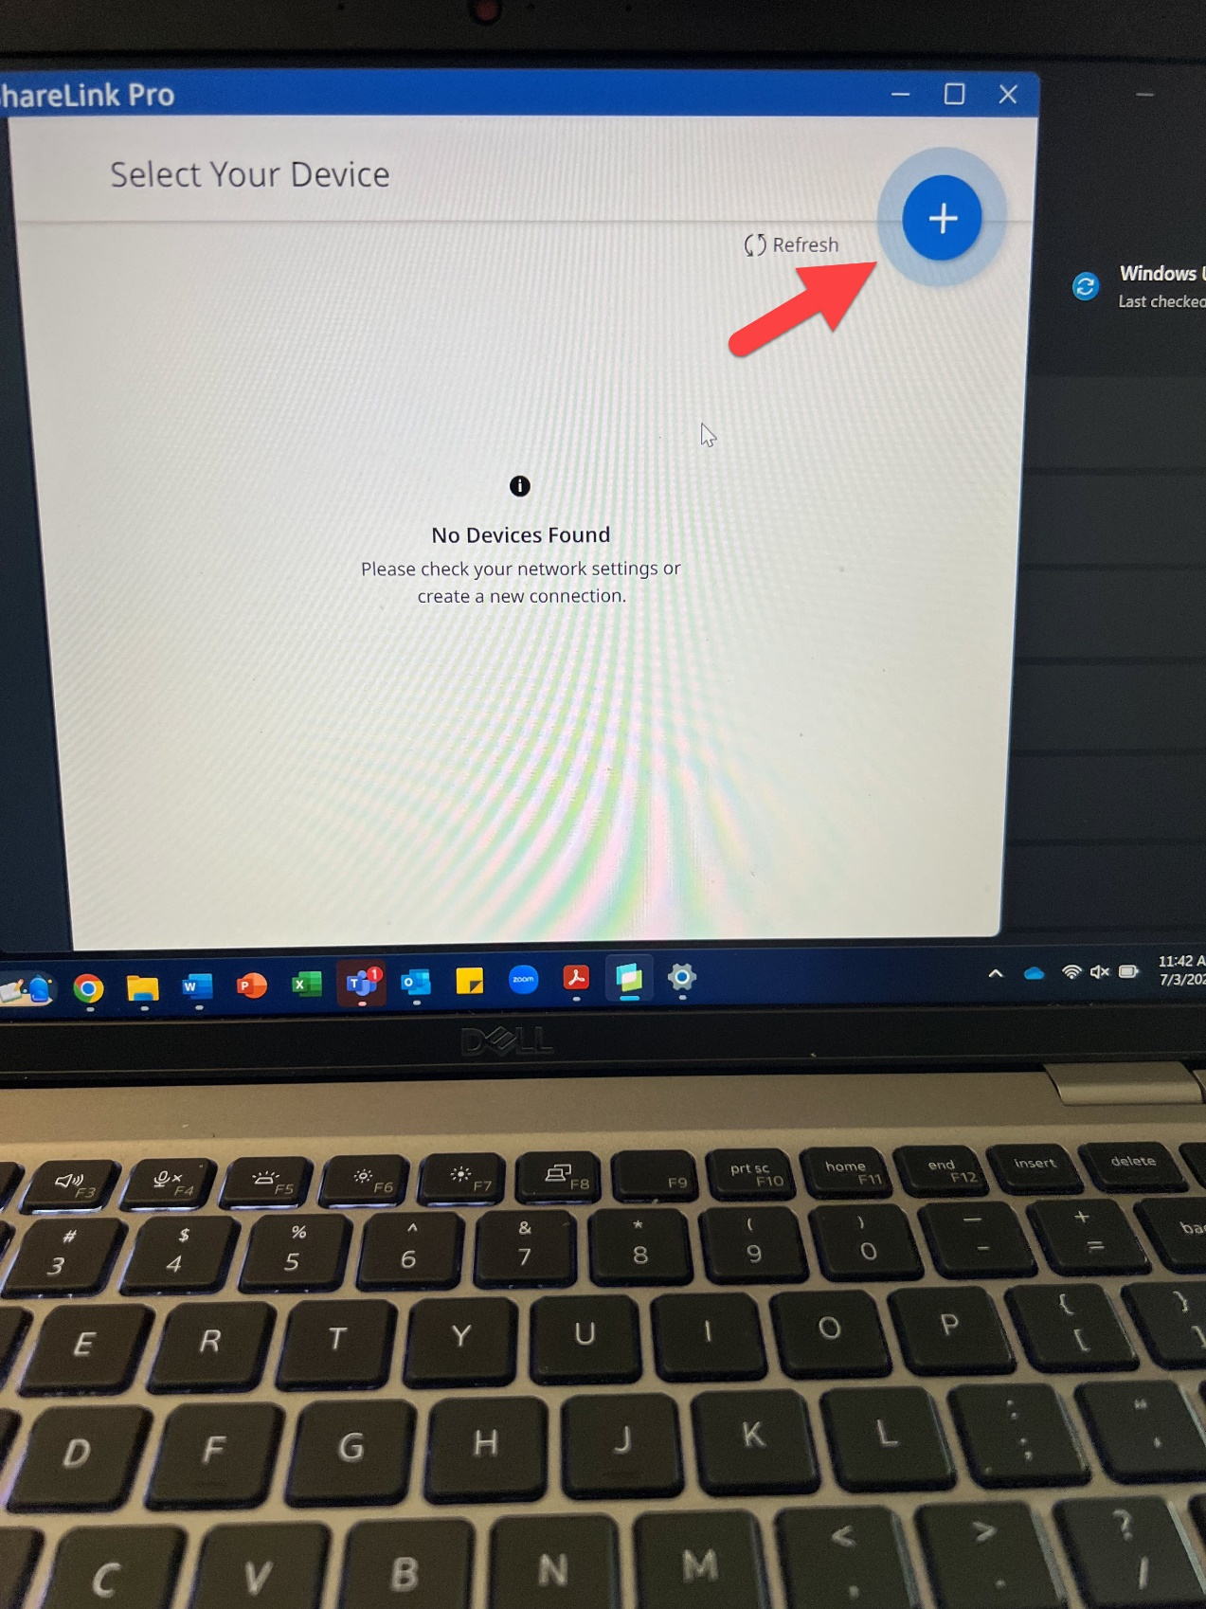

* + You will be prompted to enter the IP address from before.



* + Enter the IP address and click next.

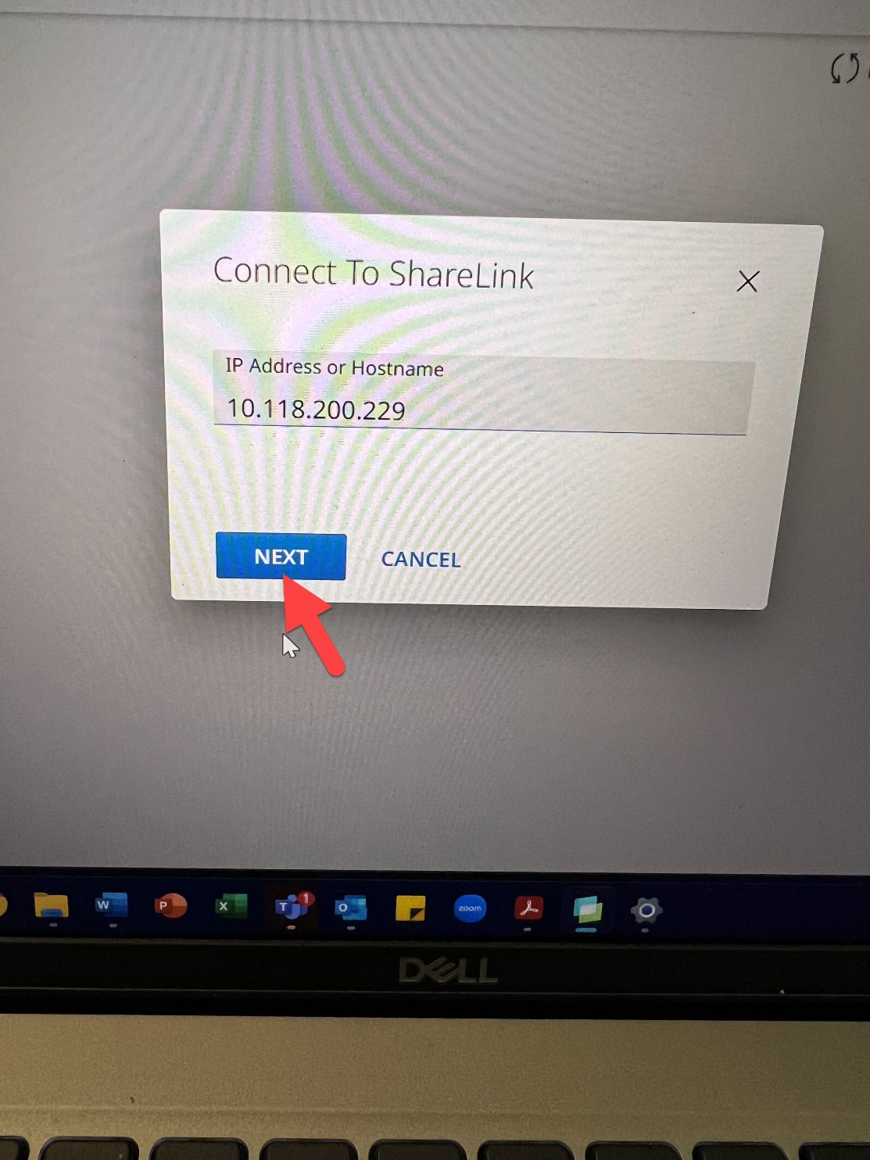

* + Click the plus sign to start sharing your screen.

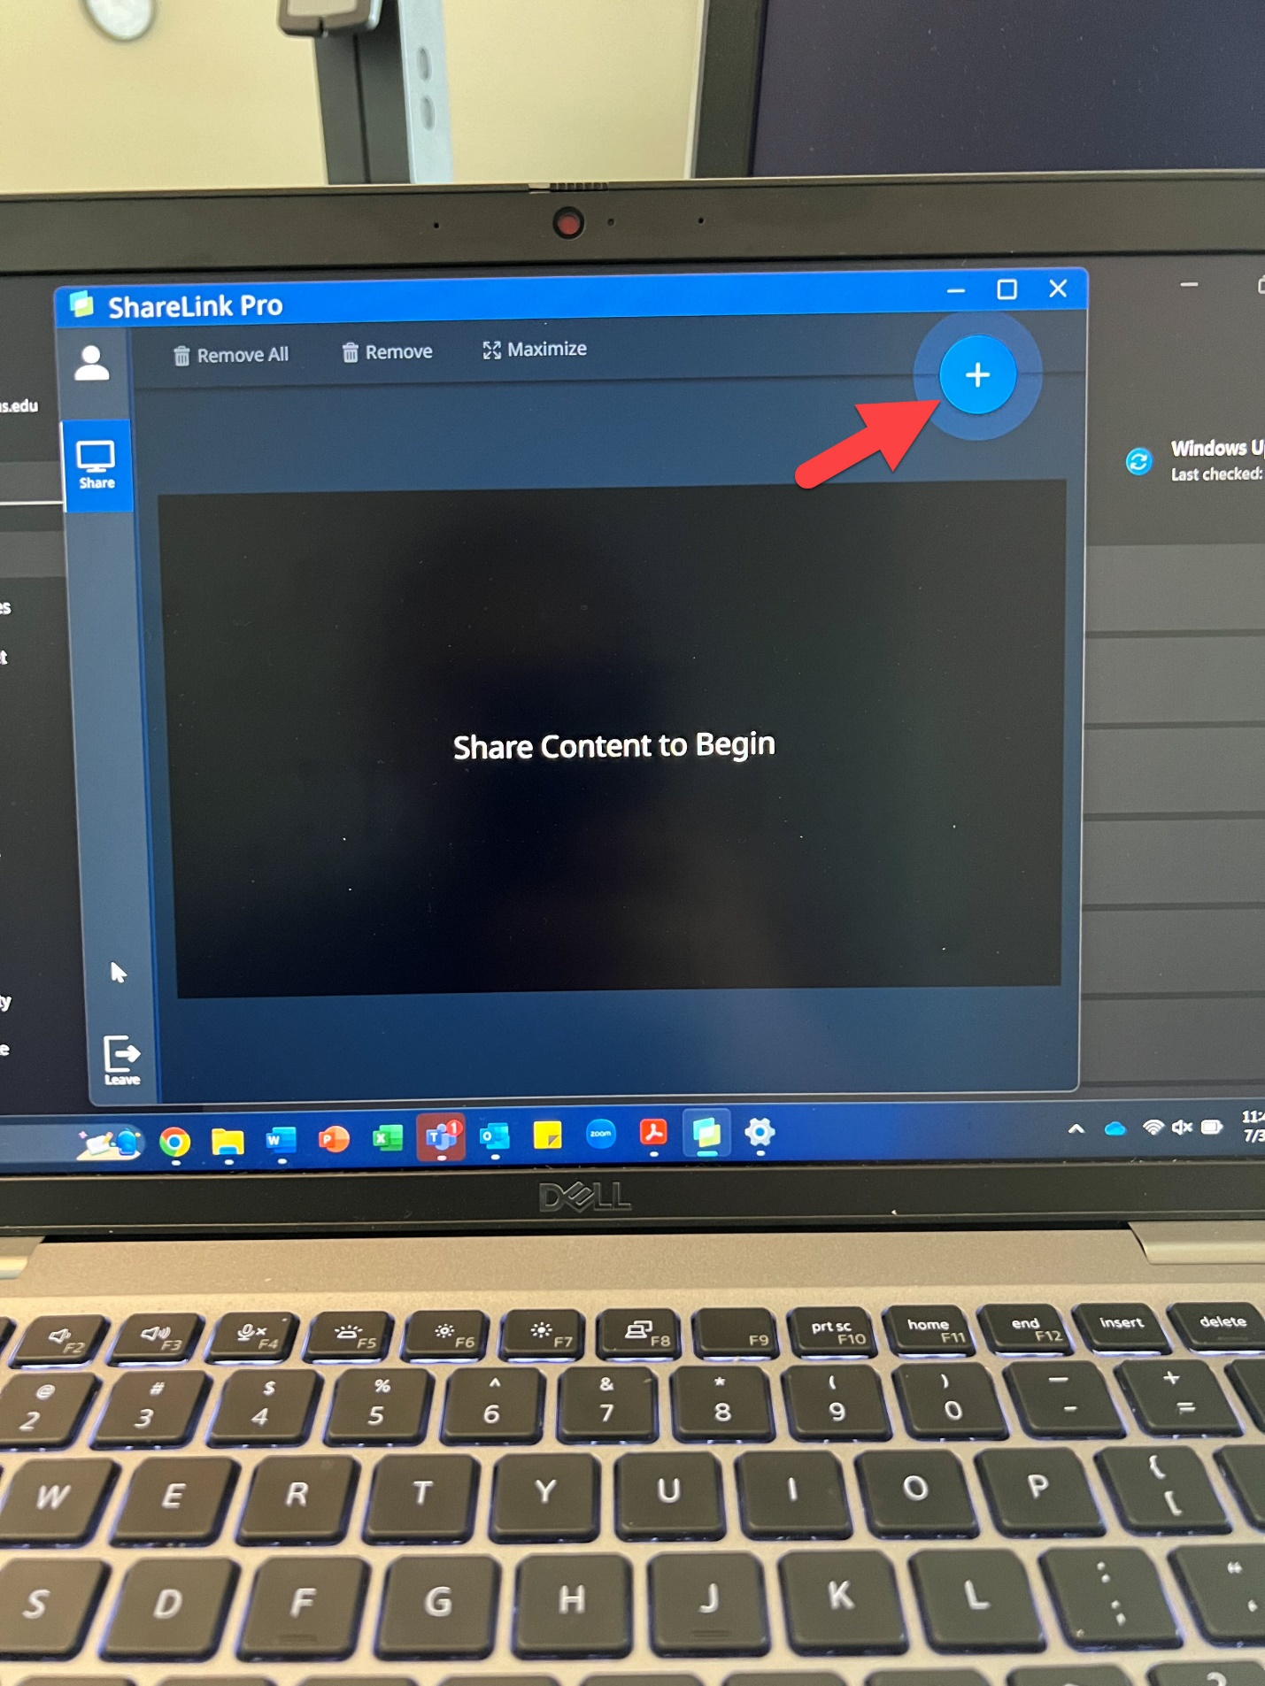

* + Select the option you want to share.

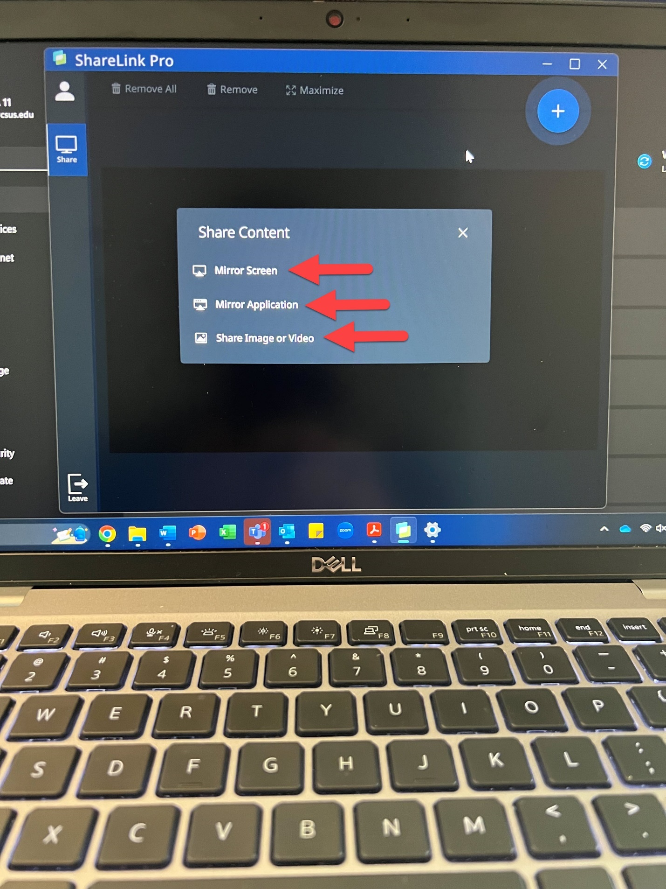

## Connecting your Laptop to ShareLink through the web browser

* + Switch the source on the touchscreen to ShareLink by tapping on ShareLink.



* + You will see this screen on the projector and or monitor.



* + At the bottom of the screen, you will see your devices IP address.



* + Open your internet browser of choice and type that number into the address bar of your internet browser.

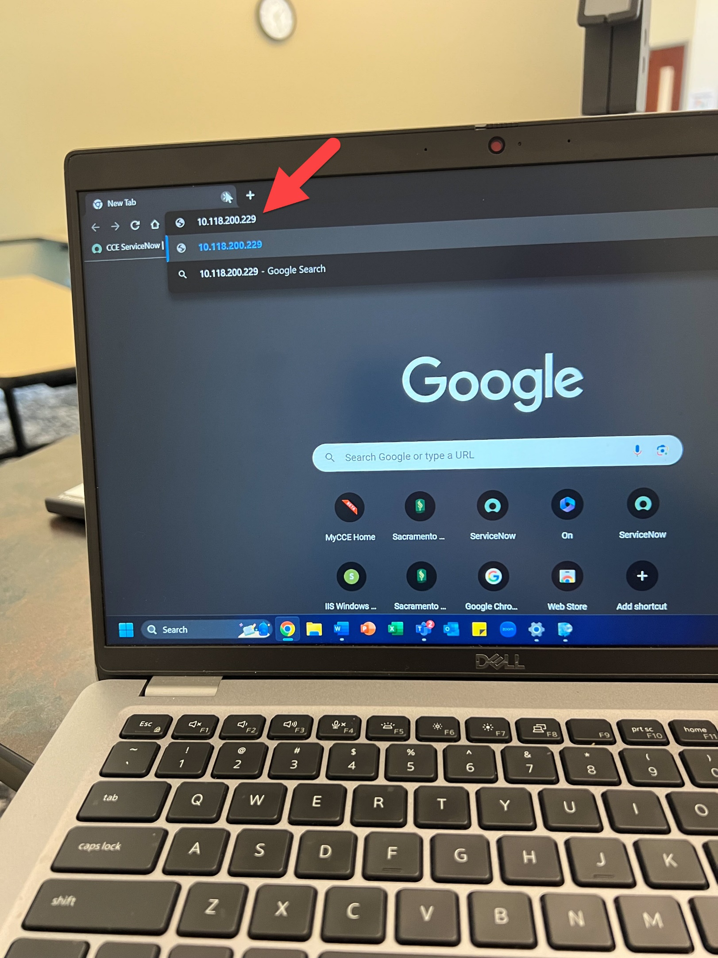

* + If you get an error saying your connection is not private, click advanced.

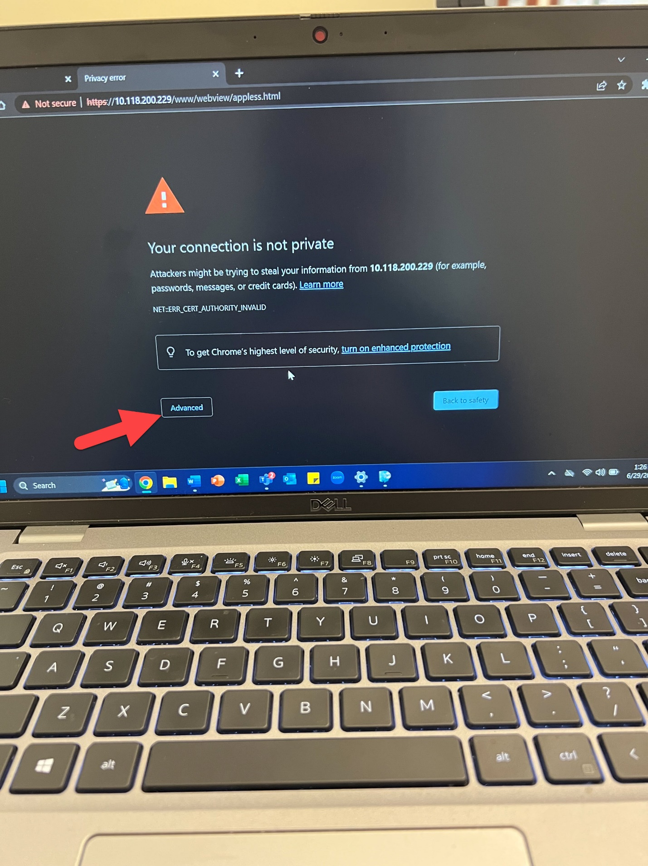

* + Then click Proceed

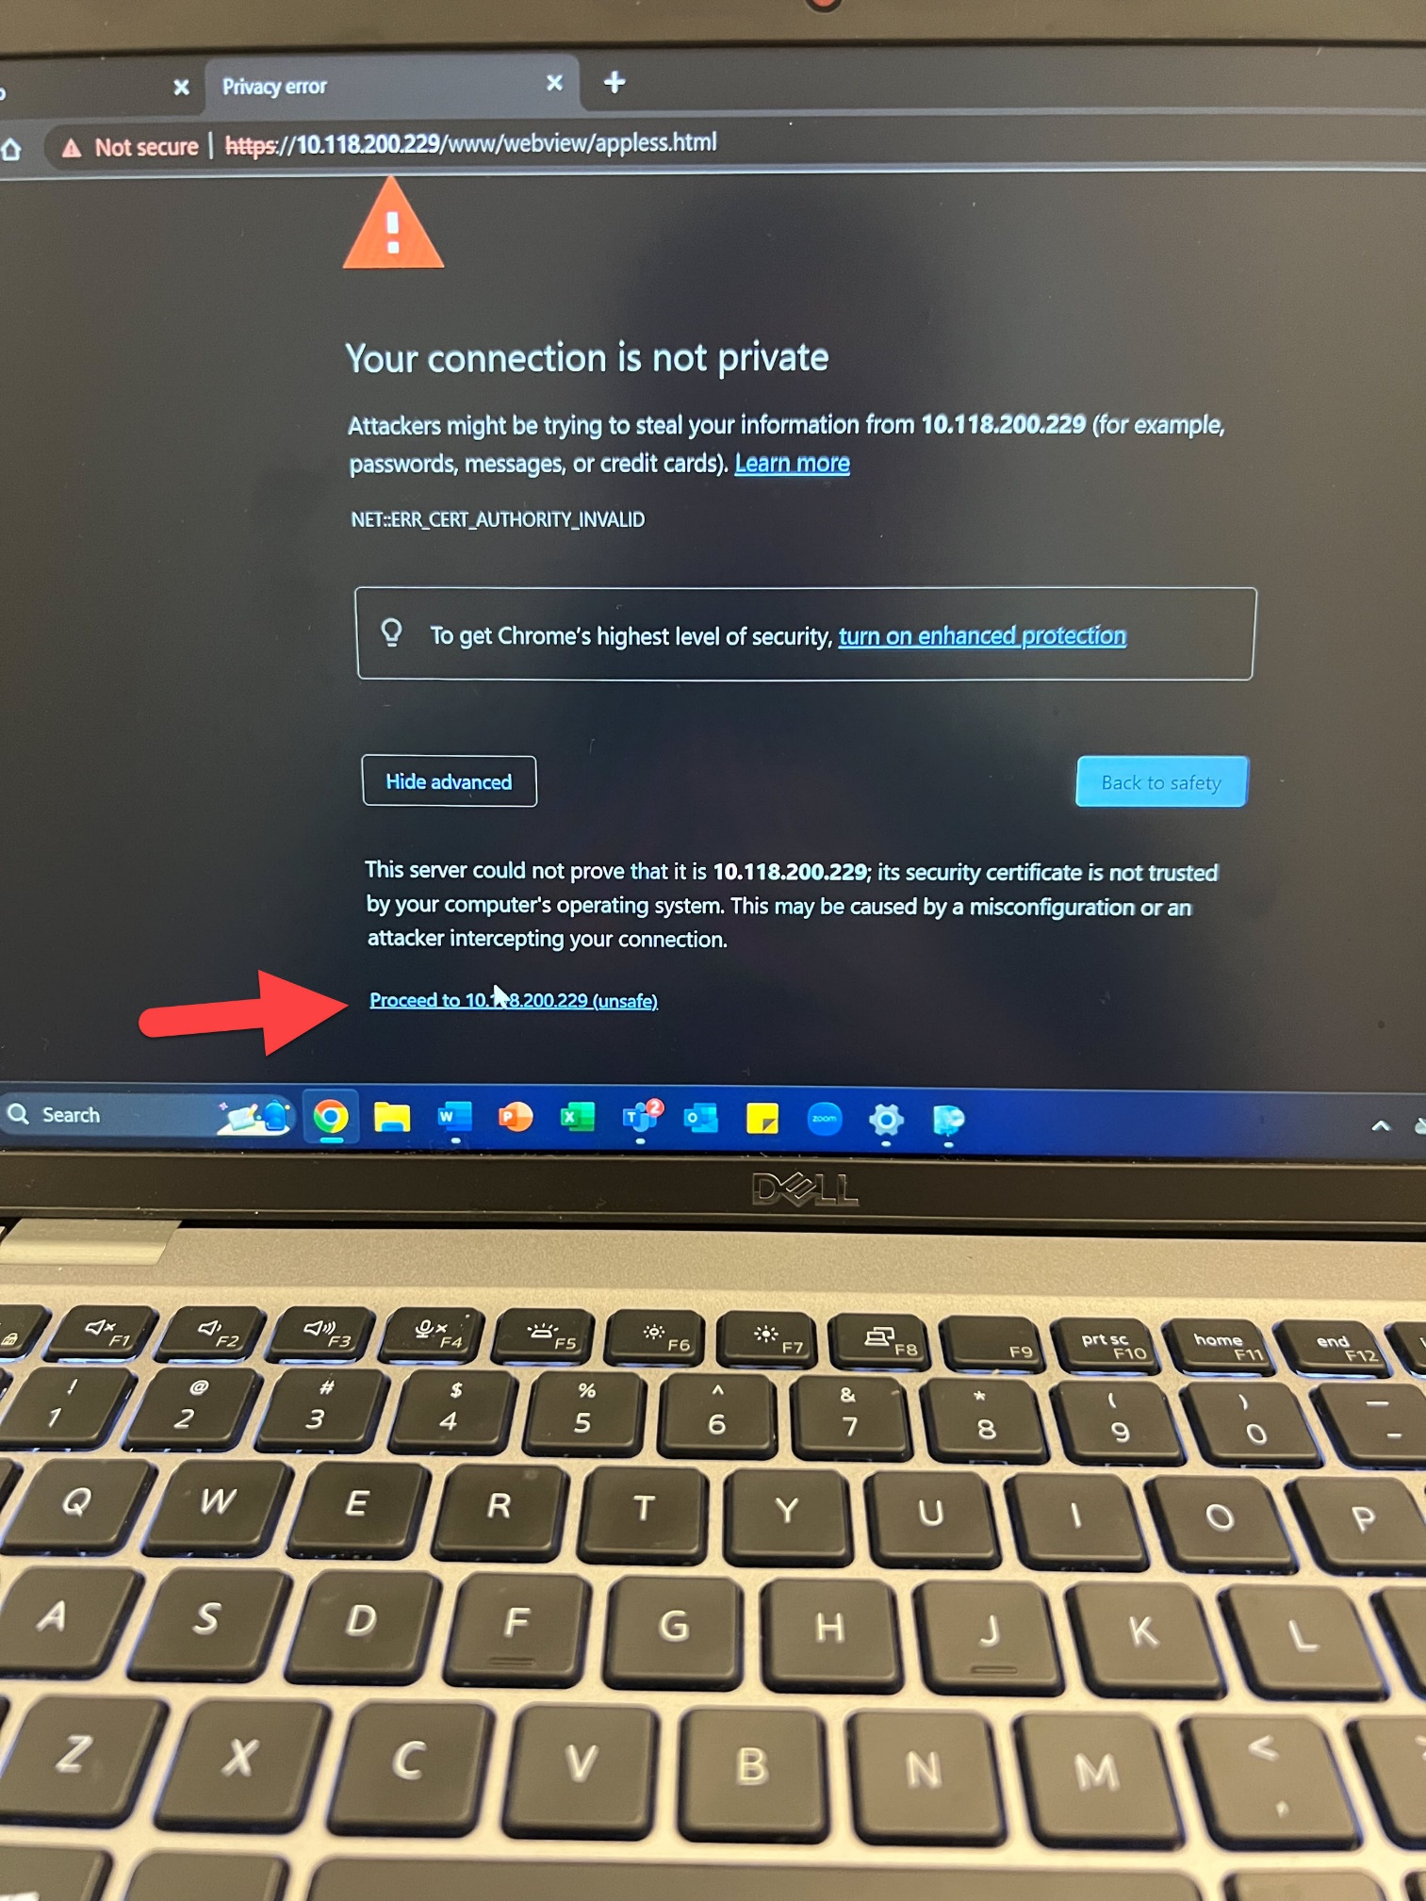

* + You will see this screen and you will click share

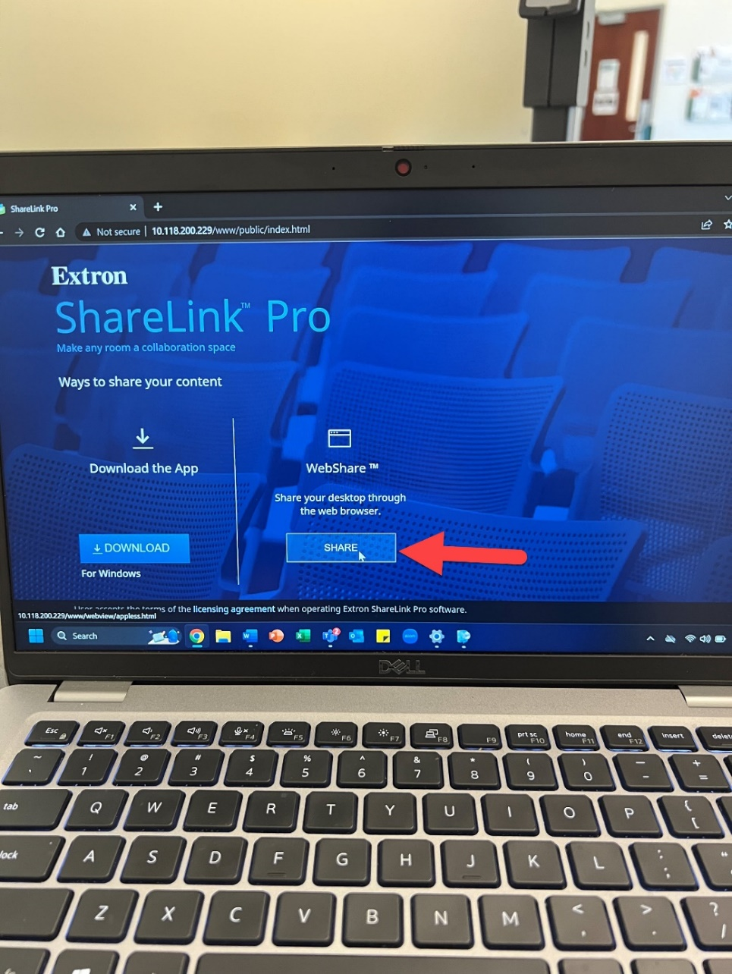

* + Enter your name and press connect.

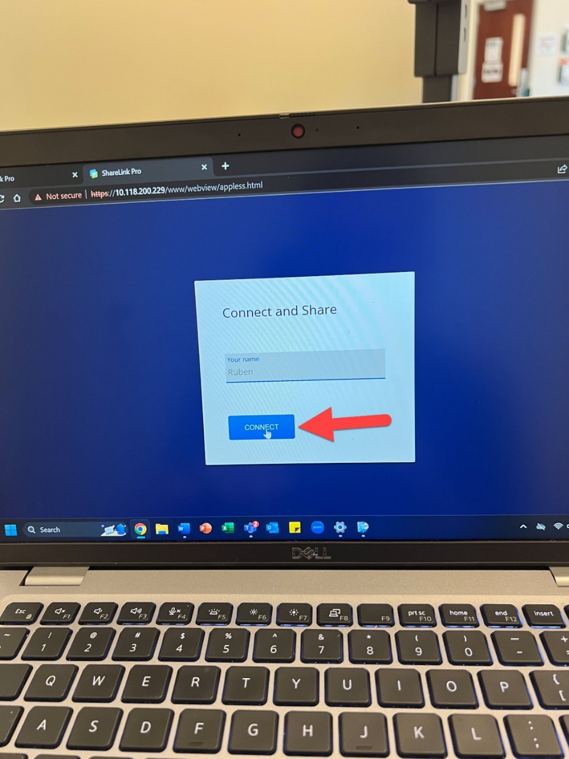

* + You will be given the option to share a browser tab, a window or the entire screen.
  + Select the option you want to share

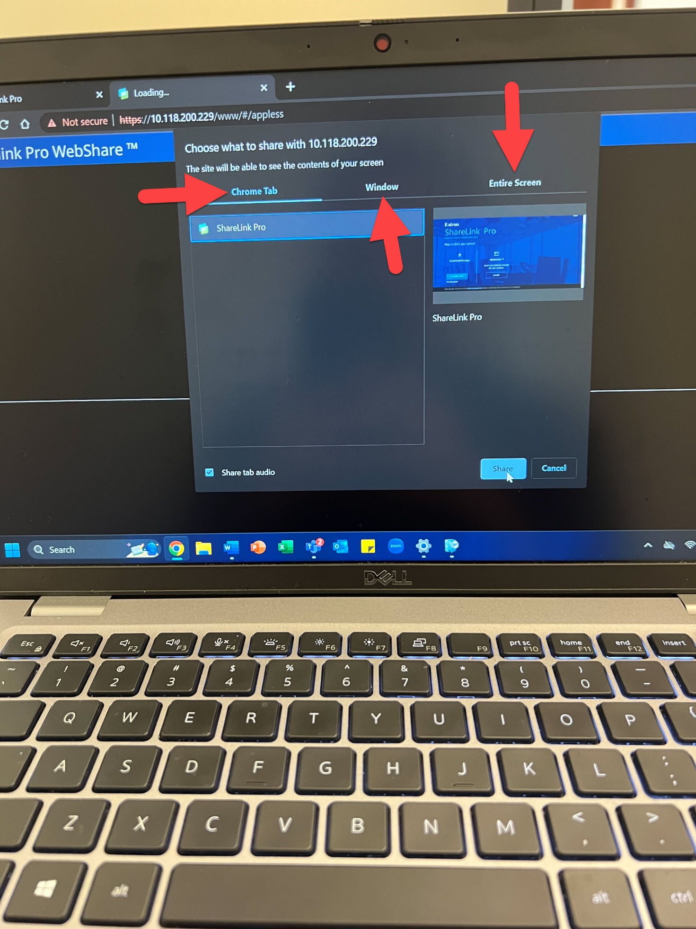

* + After you select the option you want to share, click the share button.

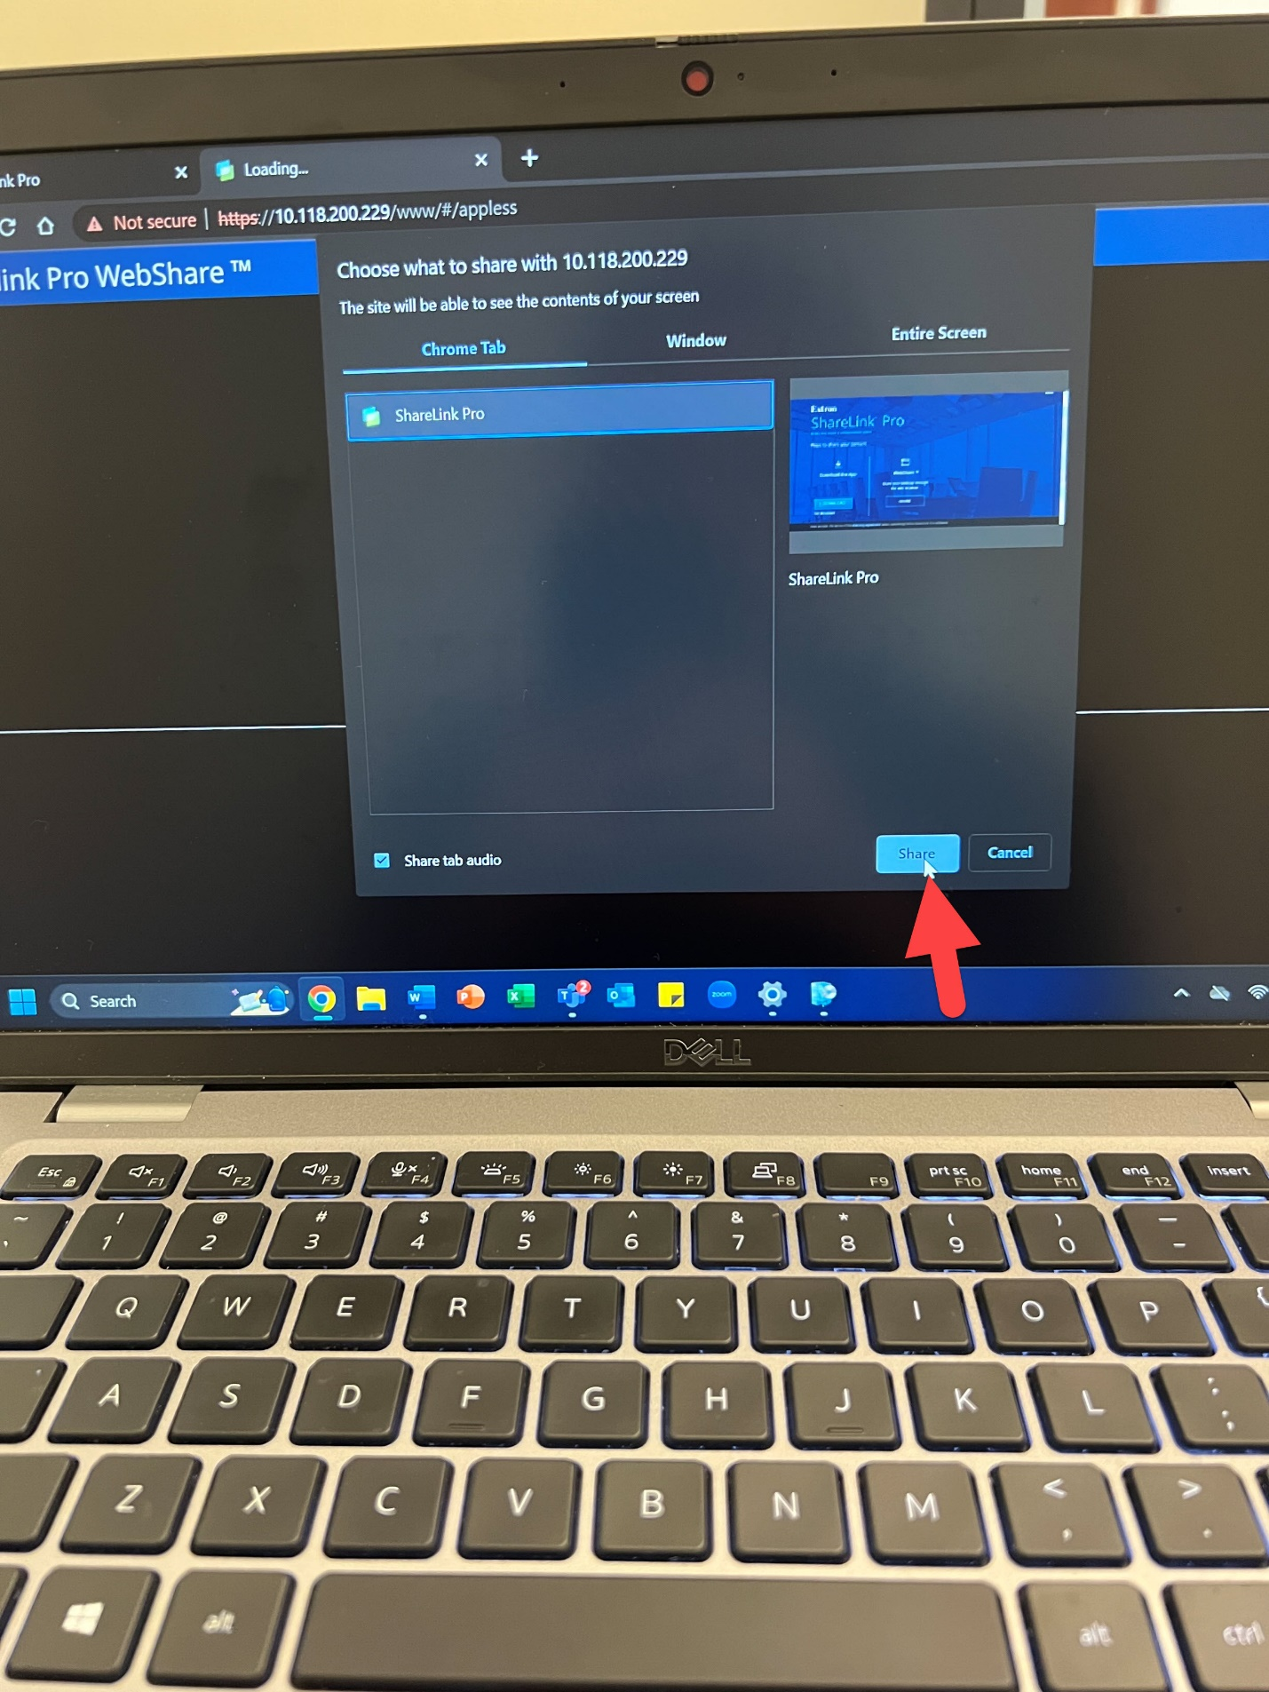

## Connecting your iPhone/iPad to ShareLink using the Mobile App

* + Switch the source on the touchscreen to ShareLink by tapping on ShareLink.



You will see this screen on the projector and or monitor.



* + At the bottom of the screen, you will see your devices IP address.



* + Download the ShareLink Pro app on the App Store

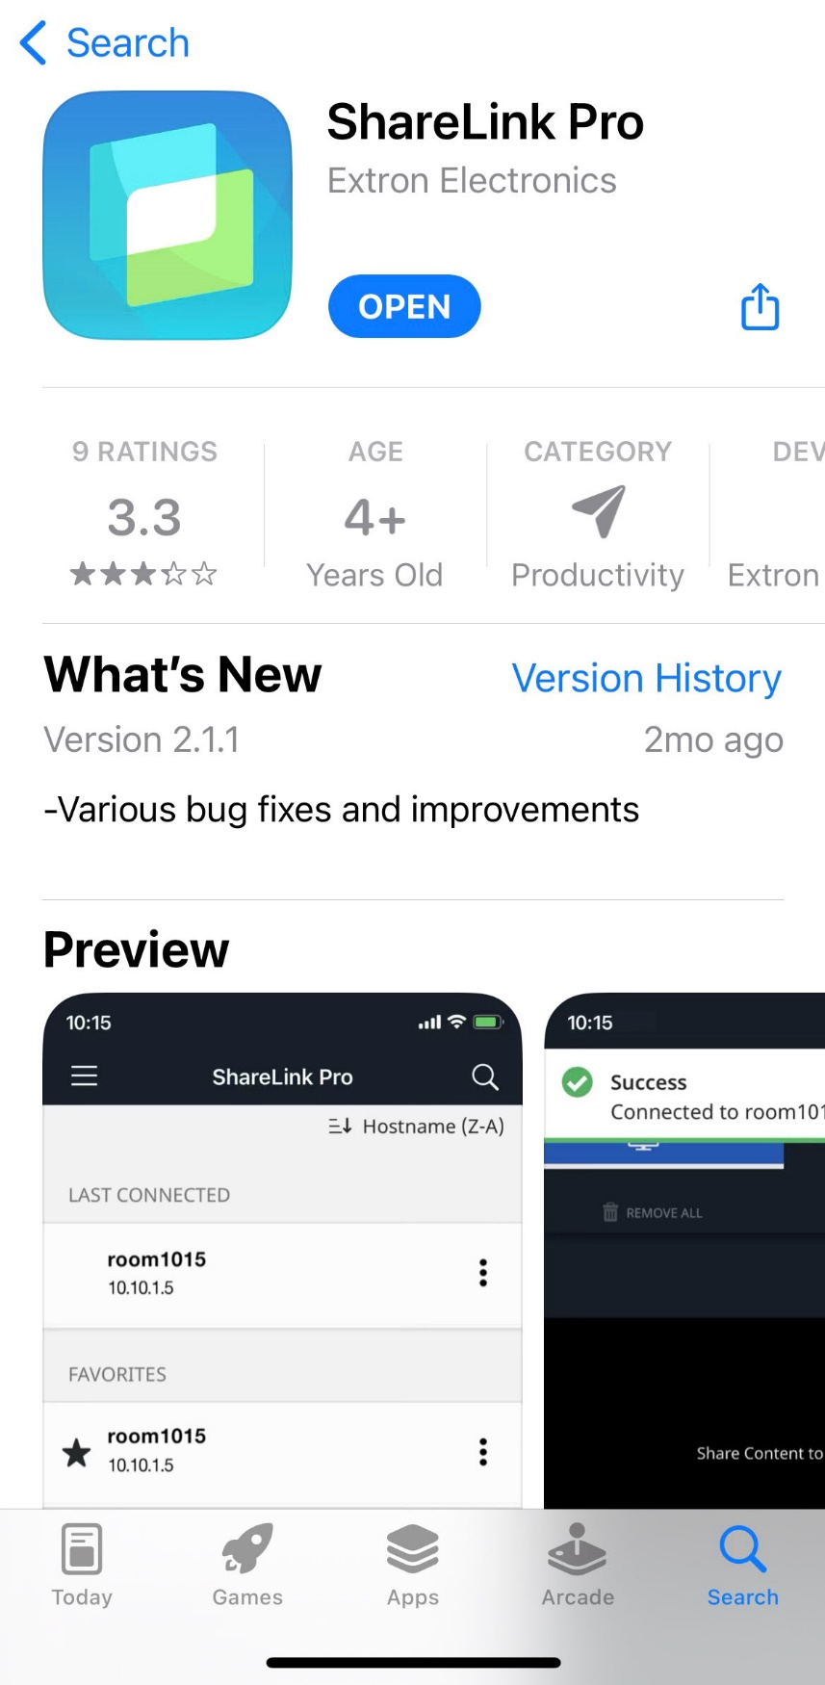

* + Open the app and tap NEW CONNECTION

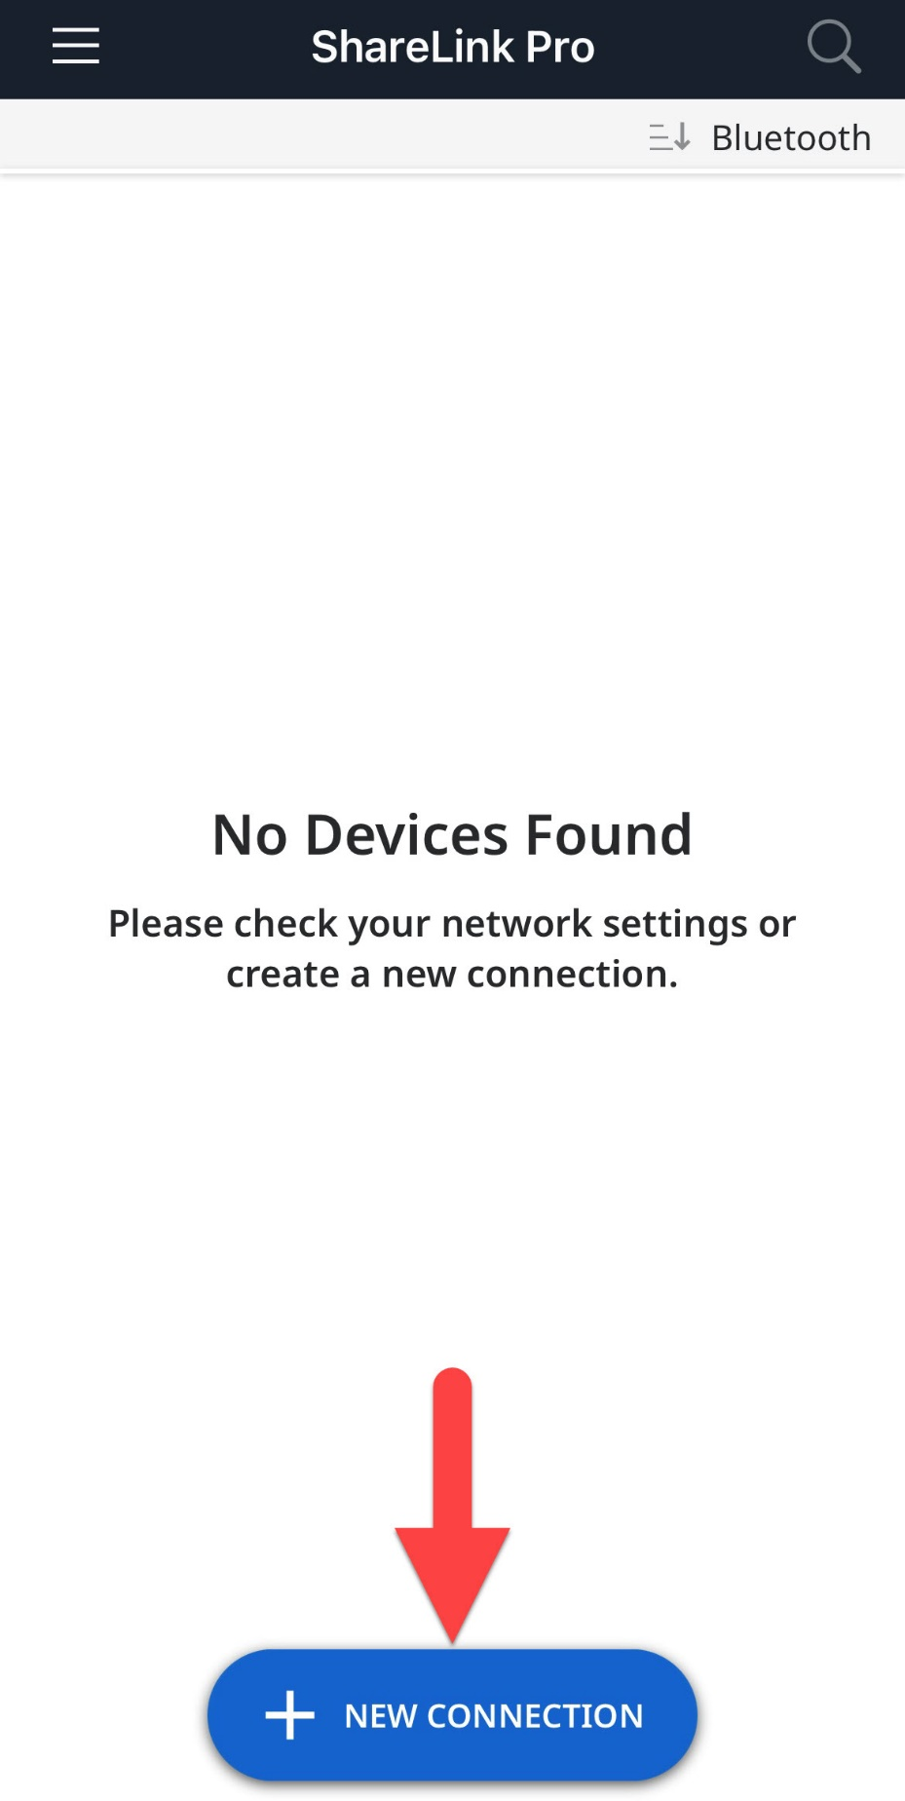

* + Enter your devices IP address and tap next.

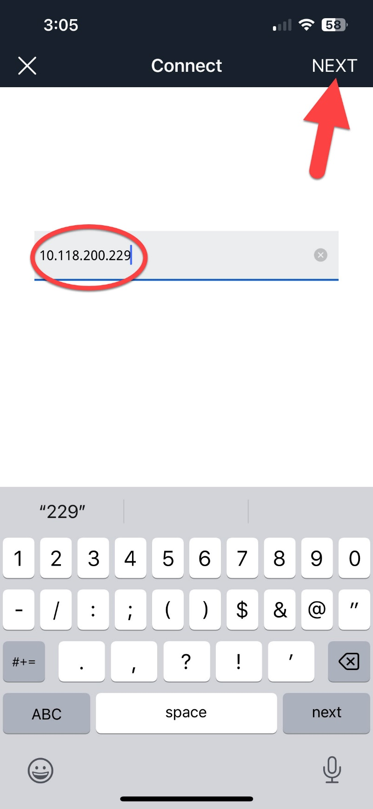

* + Tap the plus sign to start sharing your device.

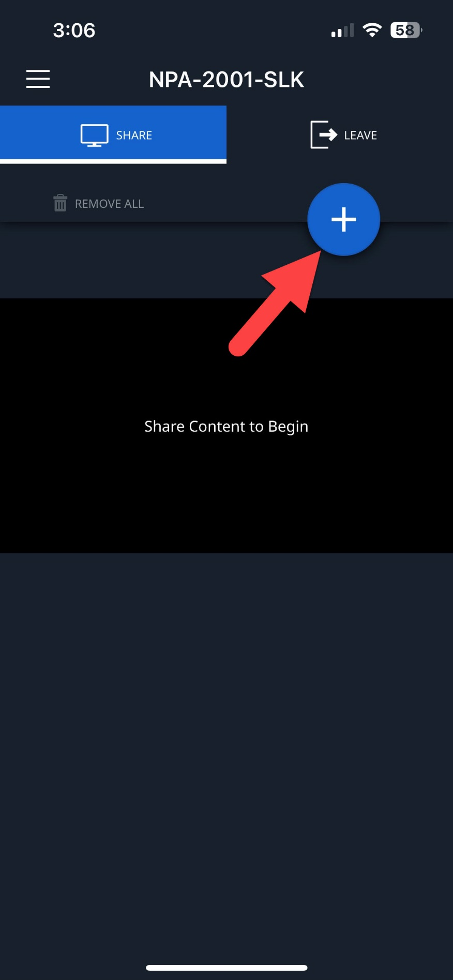

* + Select the option you want to share.

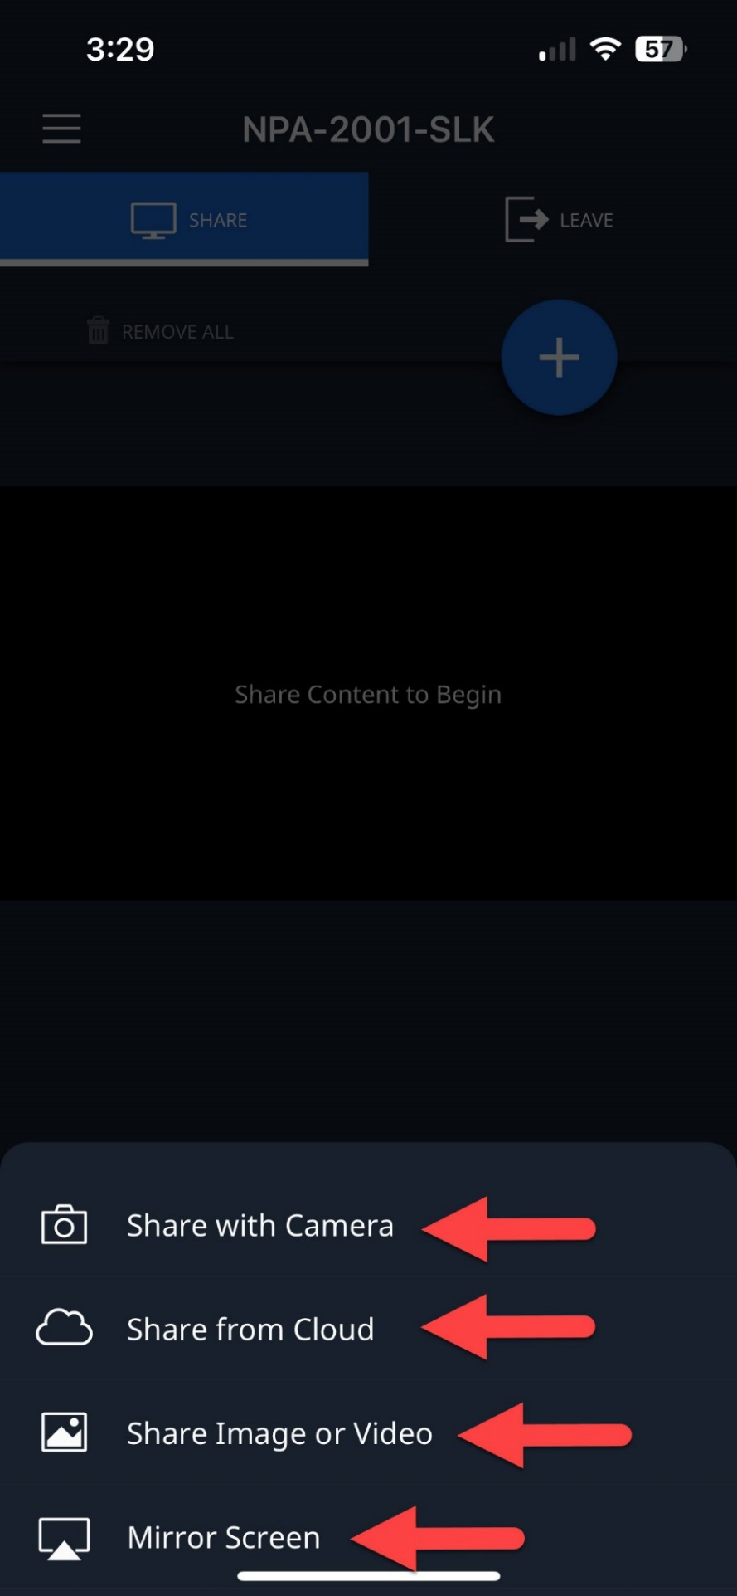

## Using the Podiums built in computer

* + Switch the source on the touchscreen to PC.

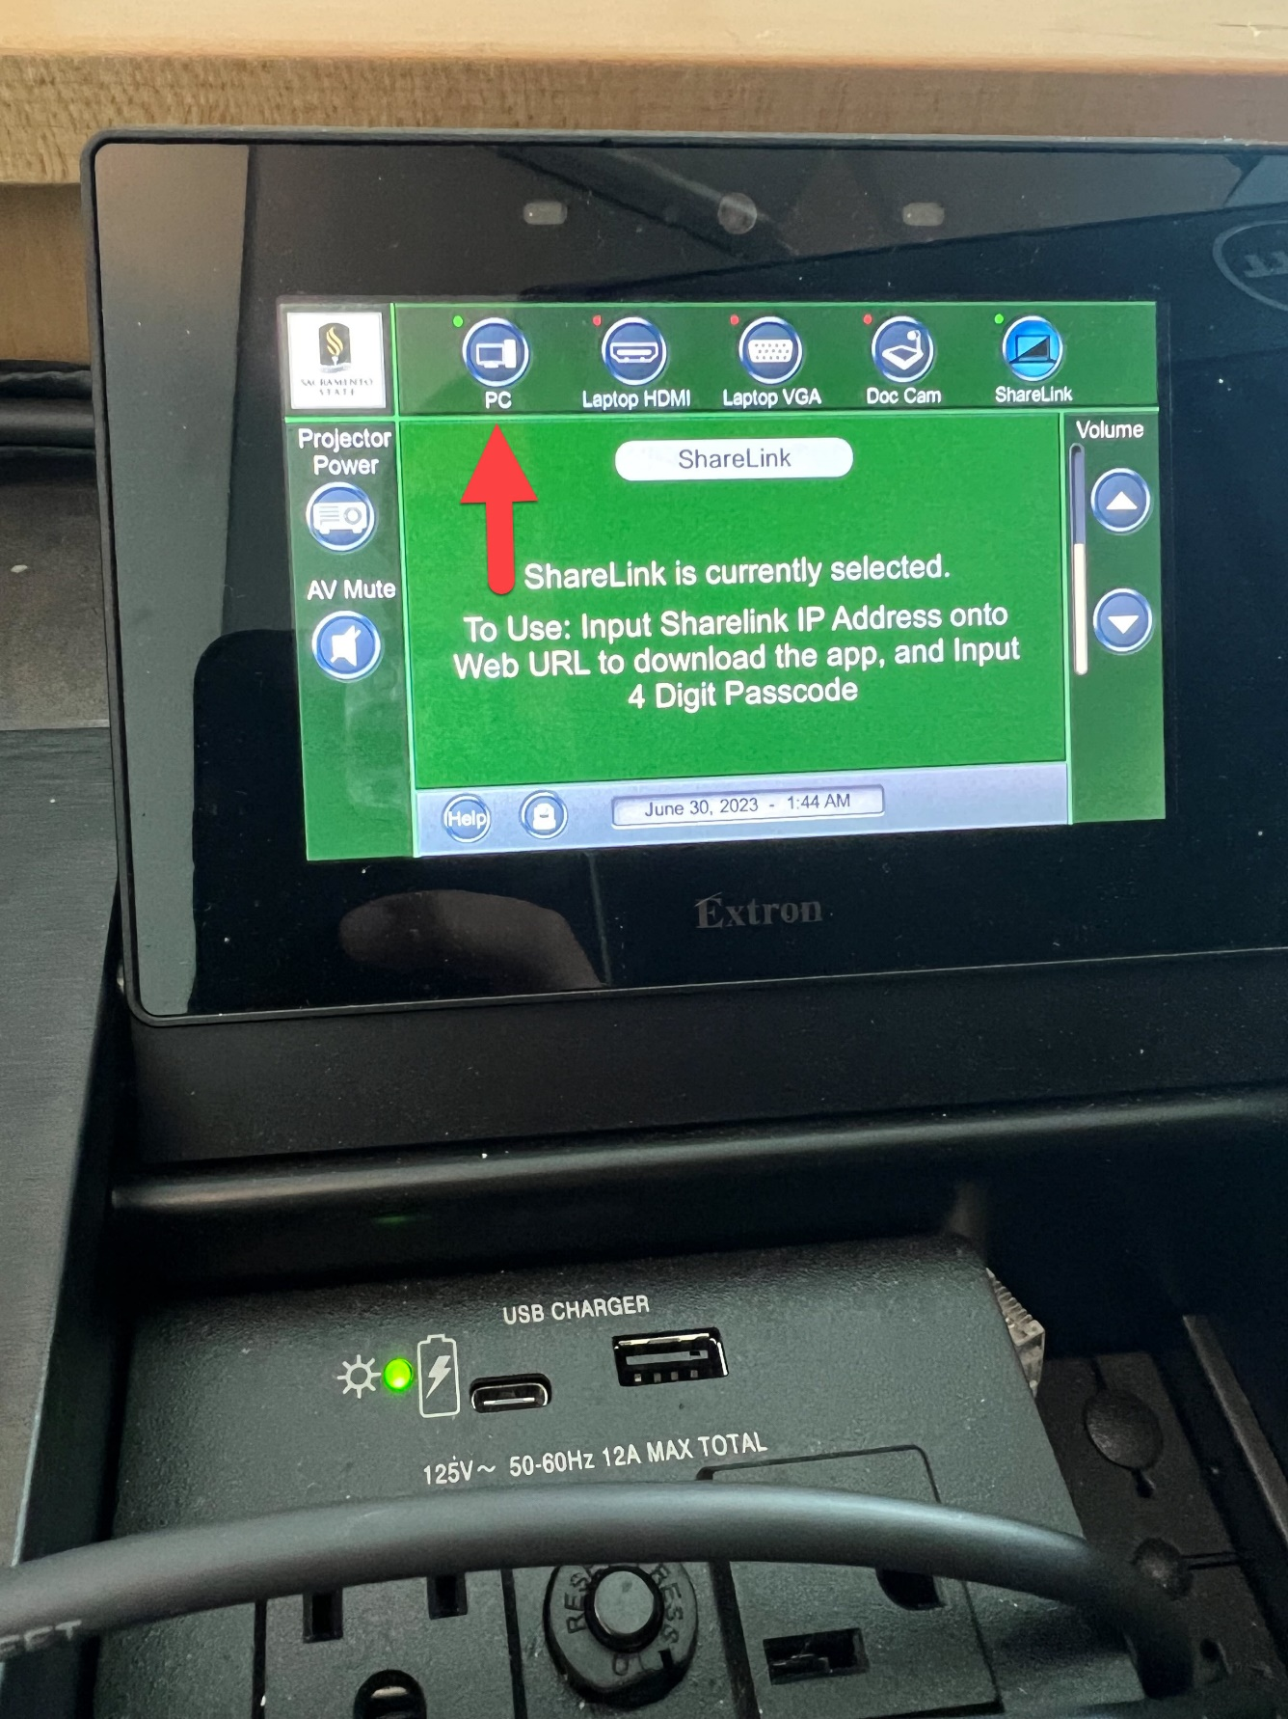

* + Pull the keyboard out from under the desk.

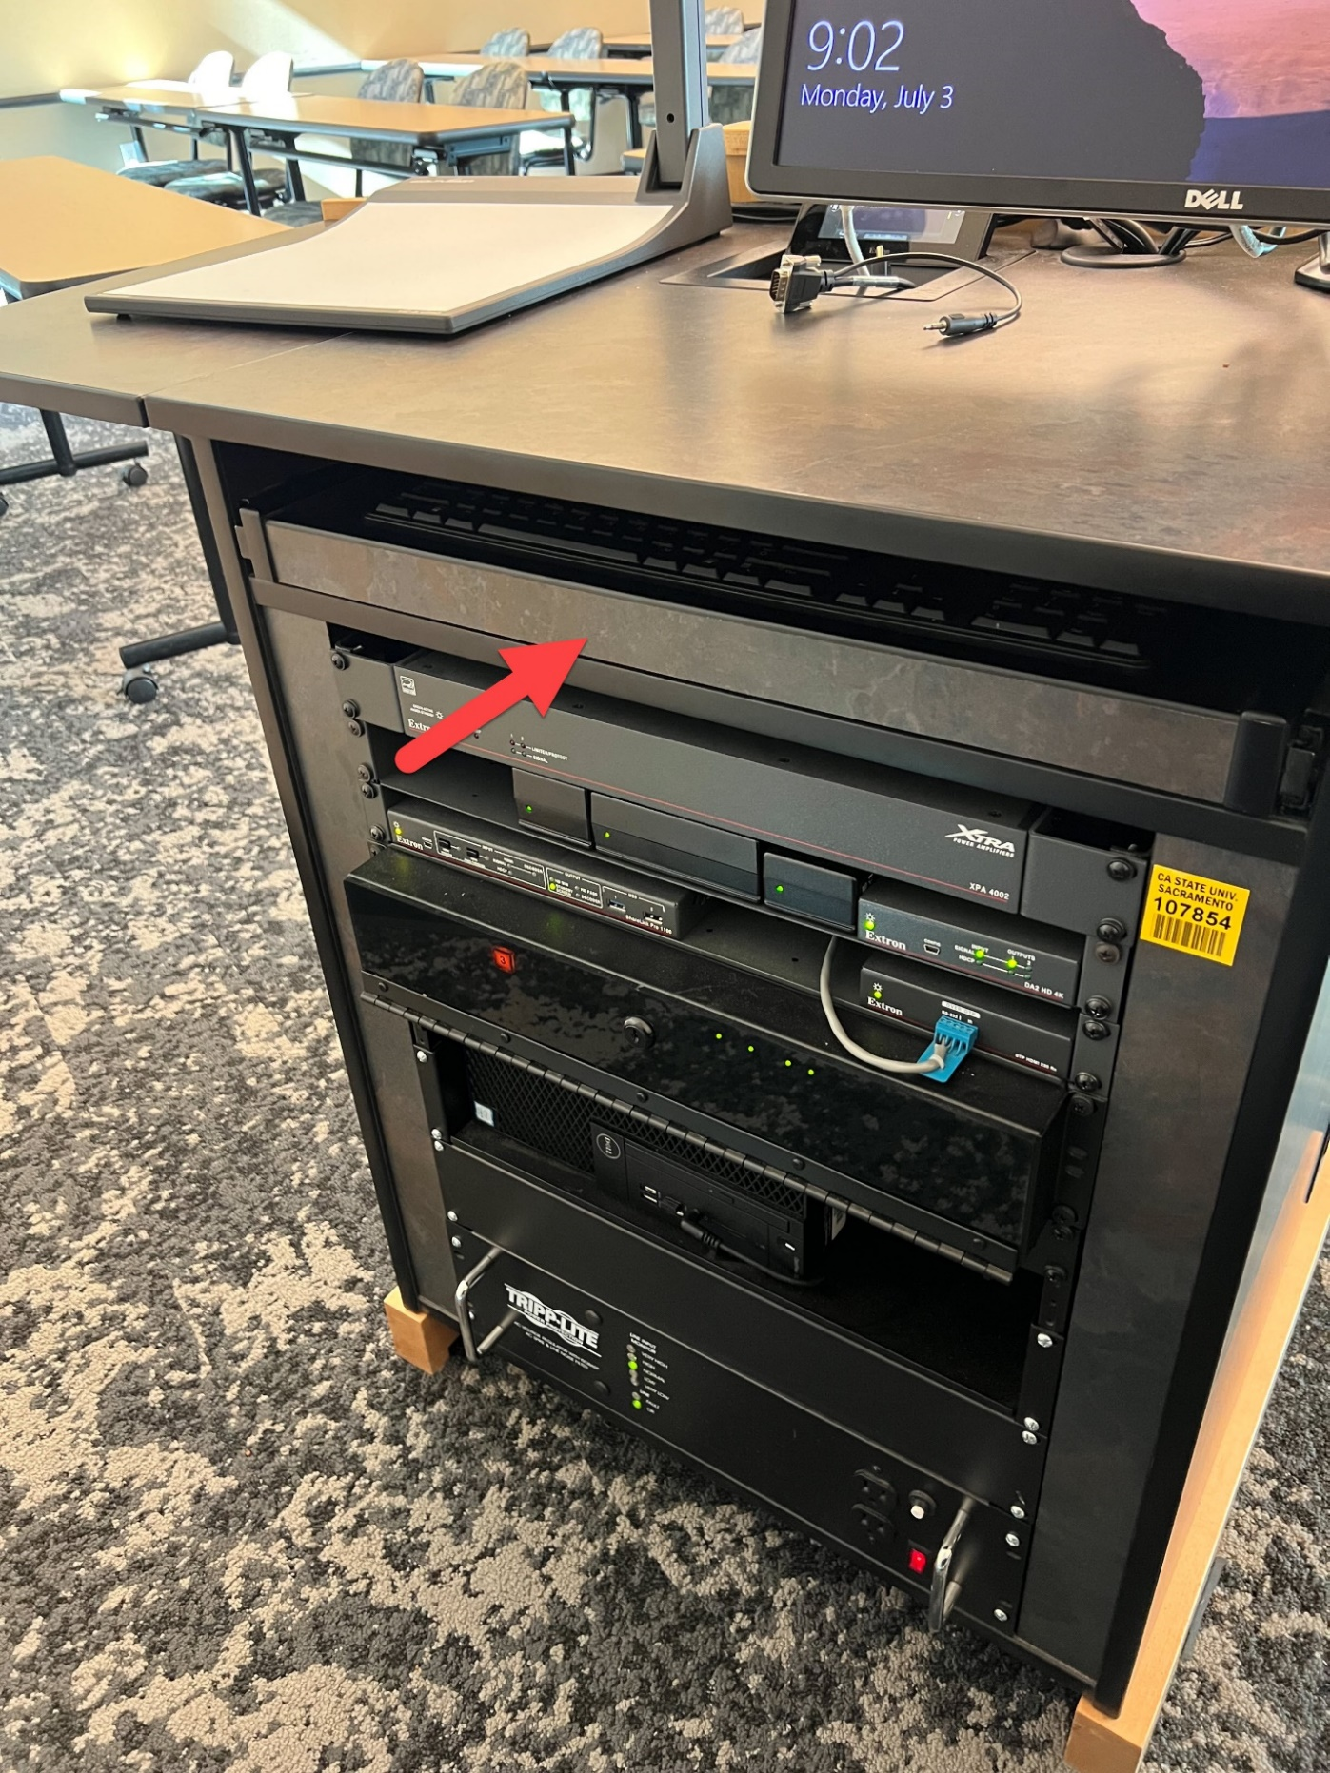

* + Log in with your Sacramento State credentials.

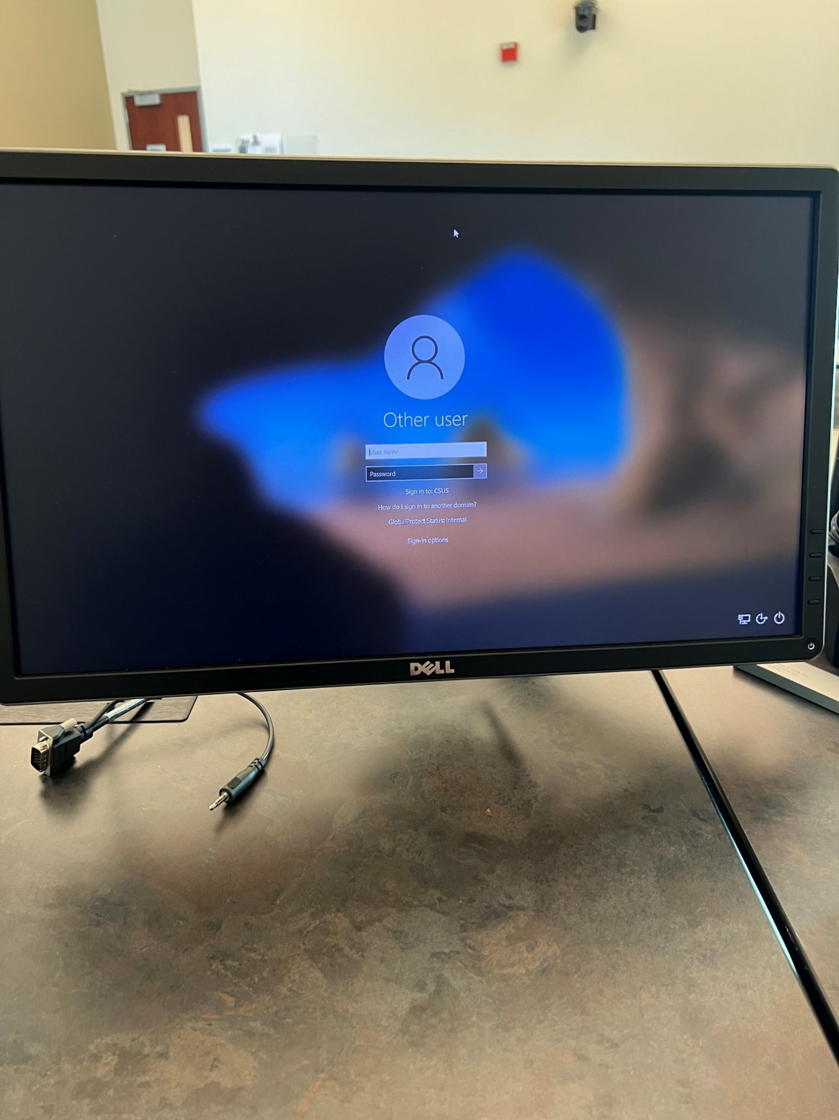

## Using the Handheld Microphone

* + Pull the handheld microphone out of its dock and move the switch up to the on position.

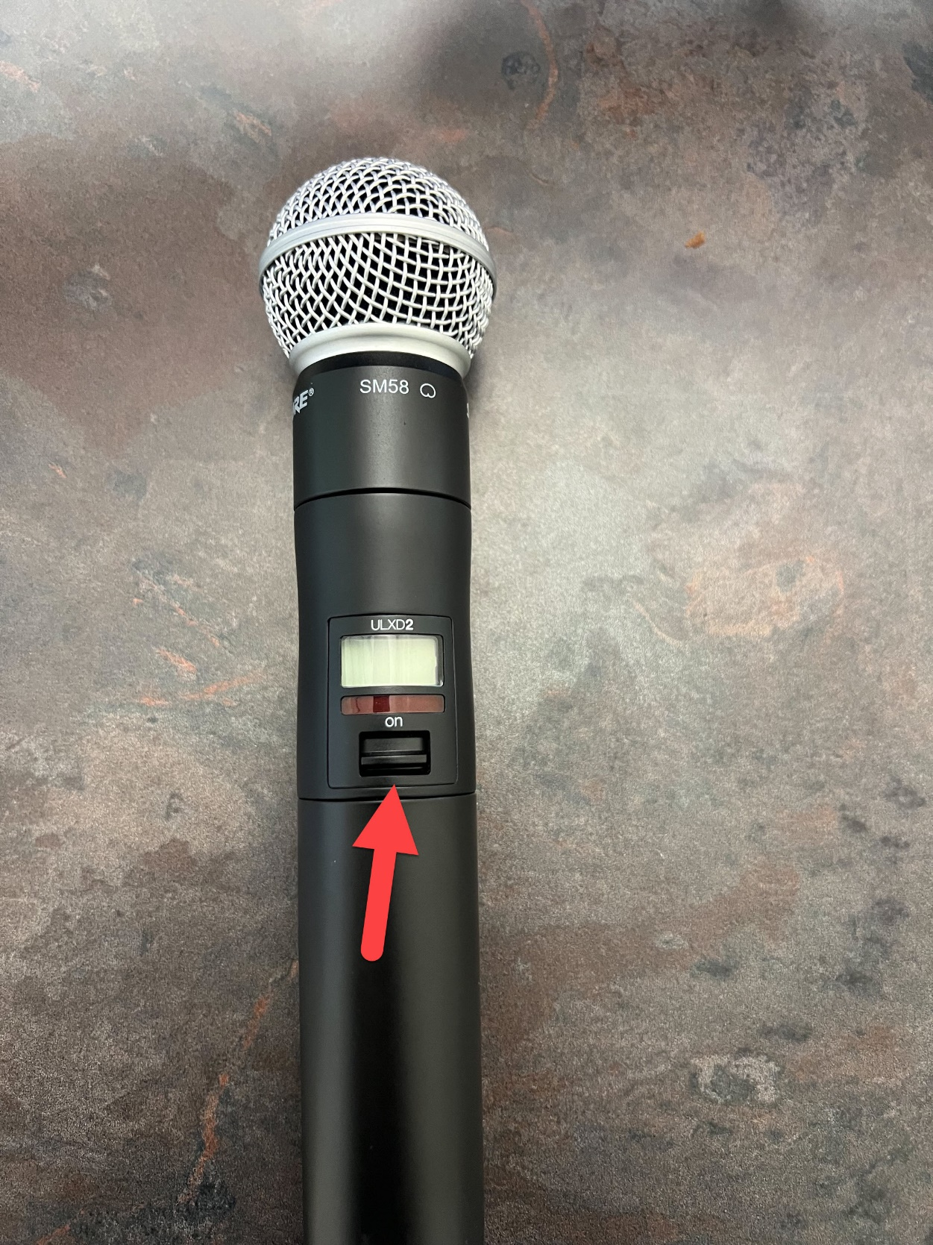

## Using the Lapel Microphone

* + Pull the Lapel microphone out of its dock.
  + Locate the power switch on the top of the microphone and switch it to the on position.

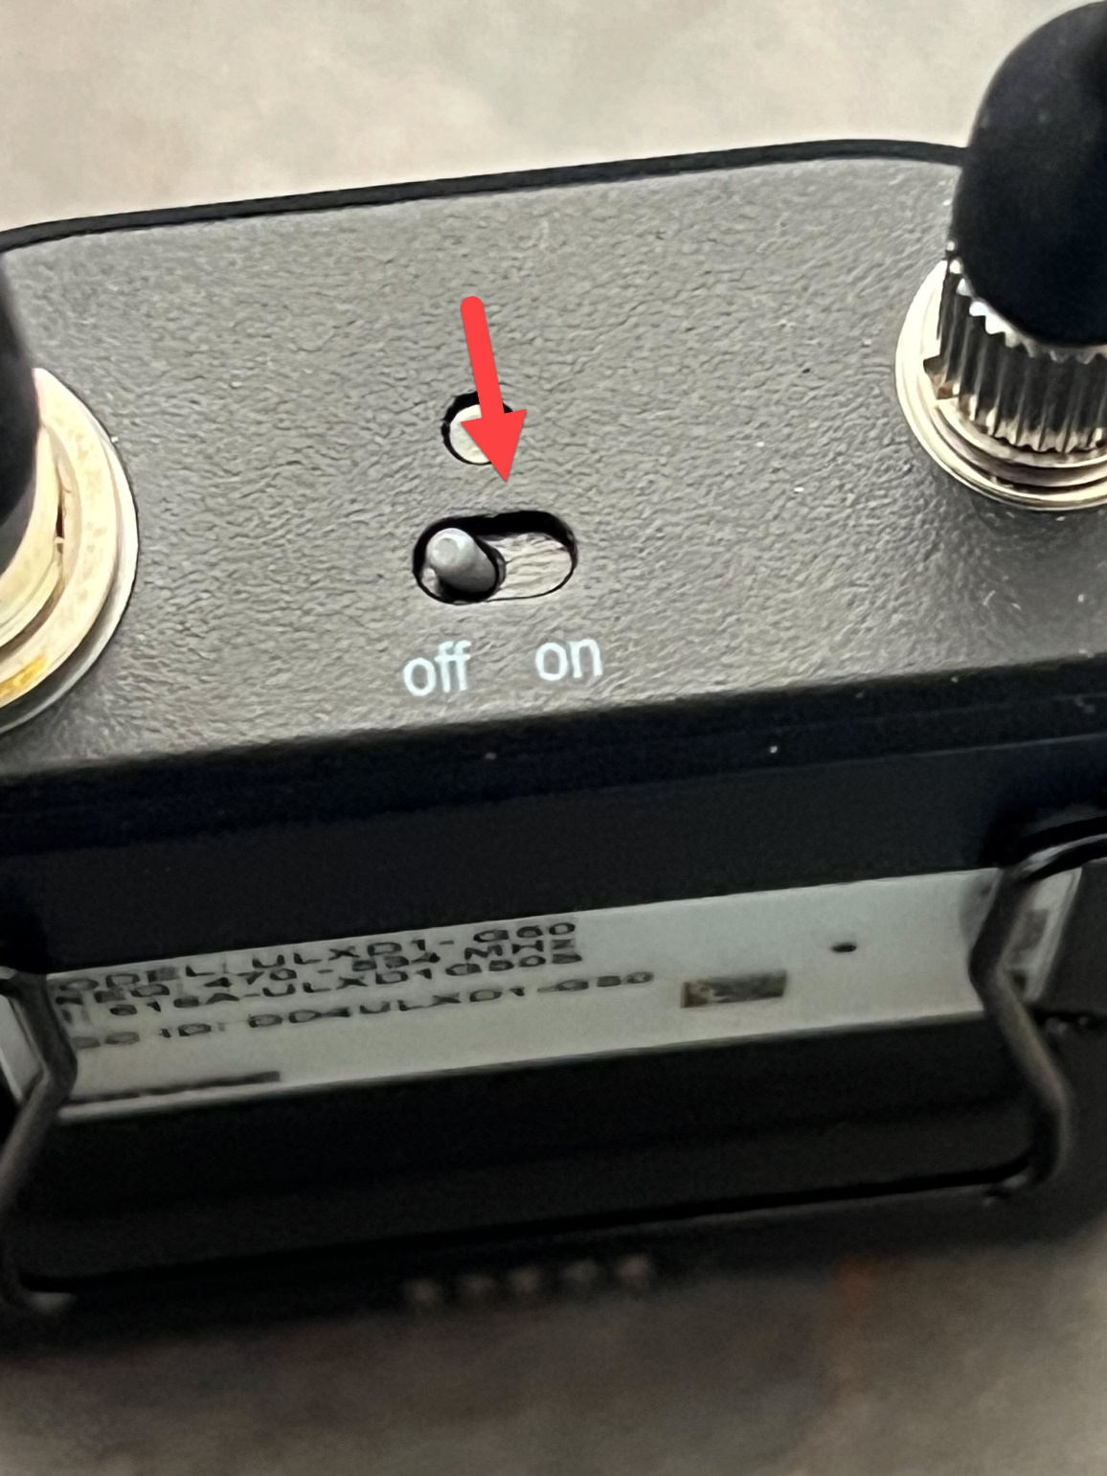

* + You will talk into this piece of the microphone.
  + This piece also has a clip so you can attach it to your shirt for easy access.

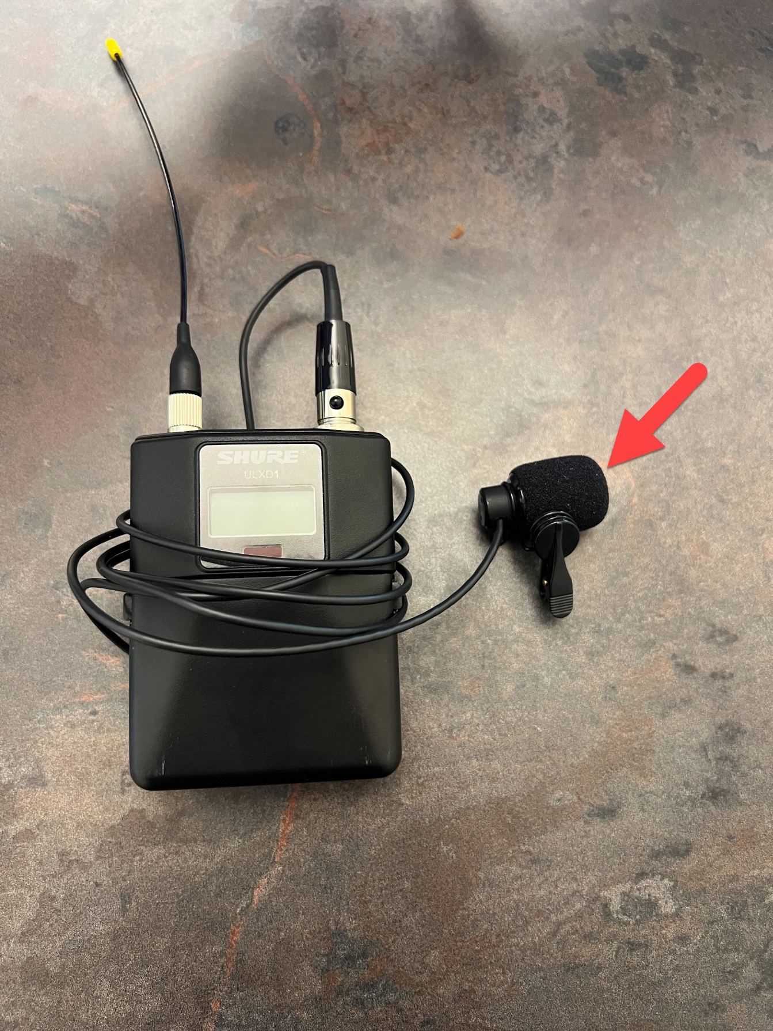

## Using the Document Camera

* + Switch the source on the touchscreen to Doc Cam.

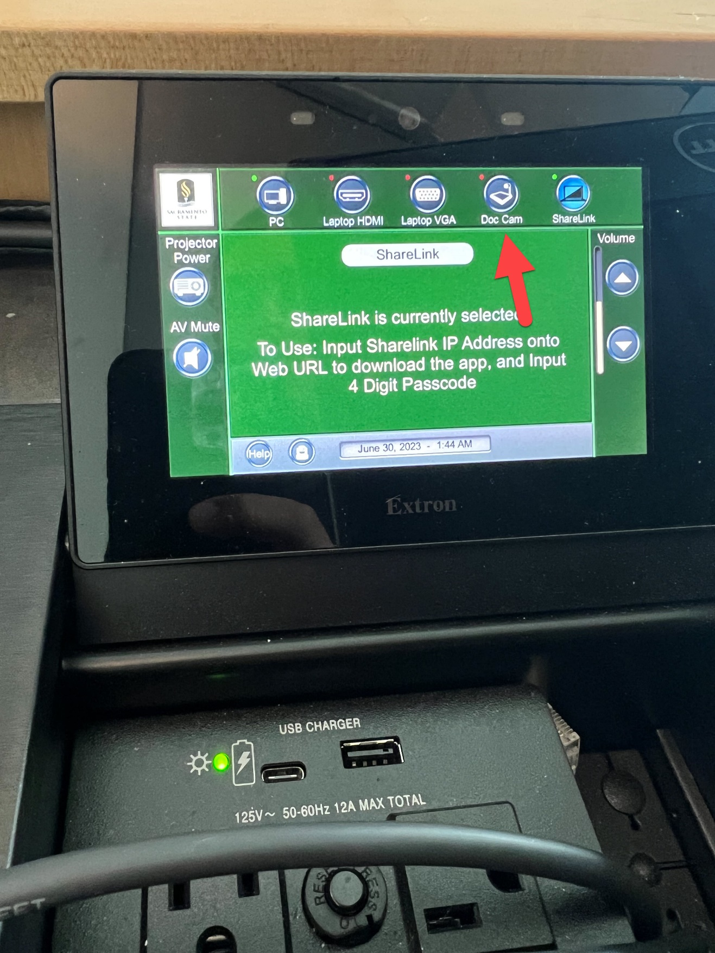

* + Place the document you want to display under the Doc Cam.

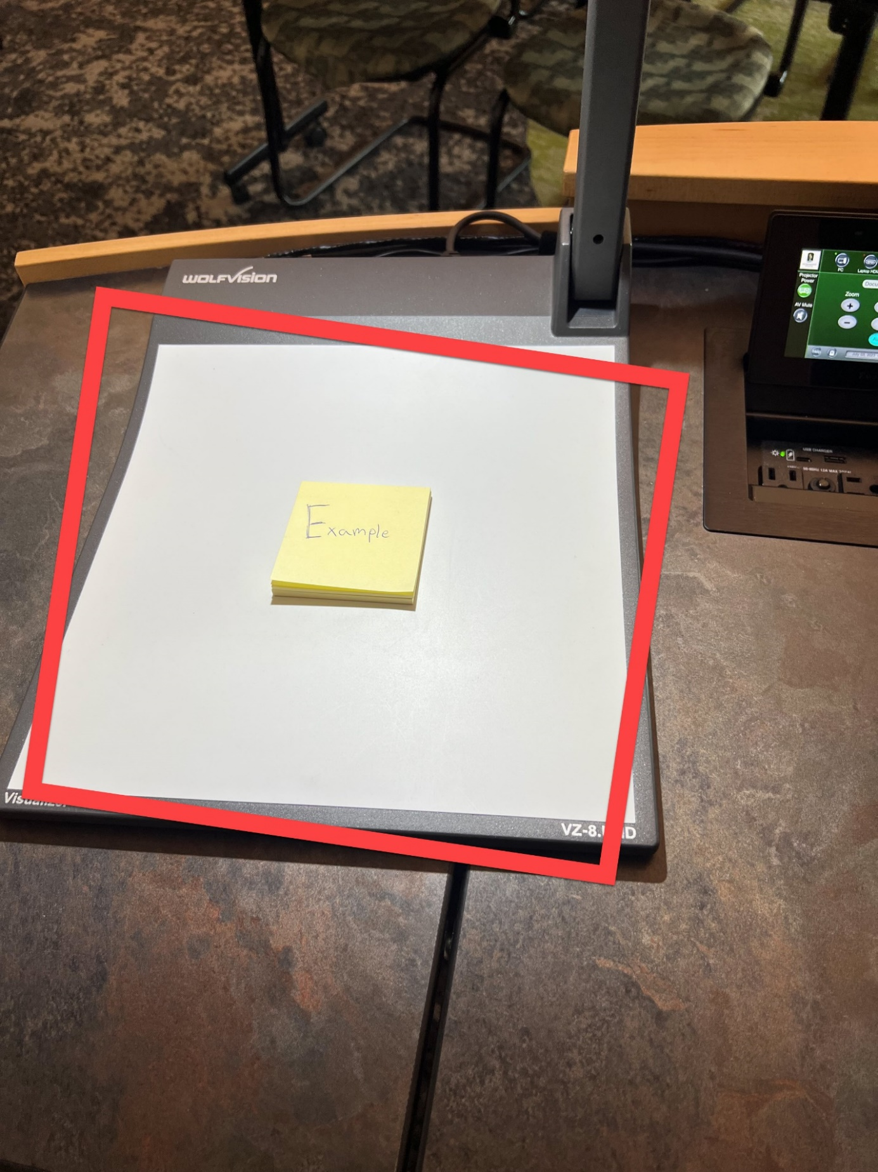

* + You can adjust the zoom of the Doc Cam by using the scroll wheel.
  + Scrolling up zooms out of your document.
  + Scrolling down zooms in to your document.

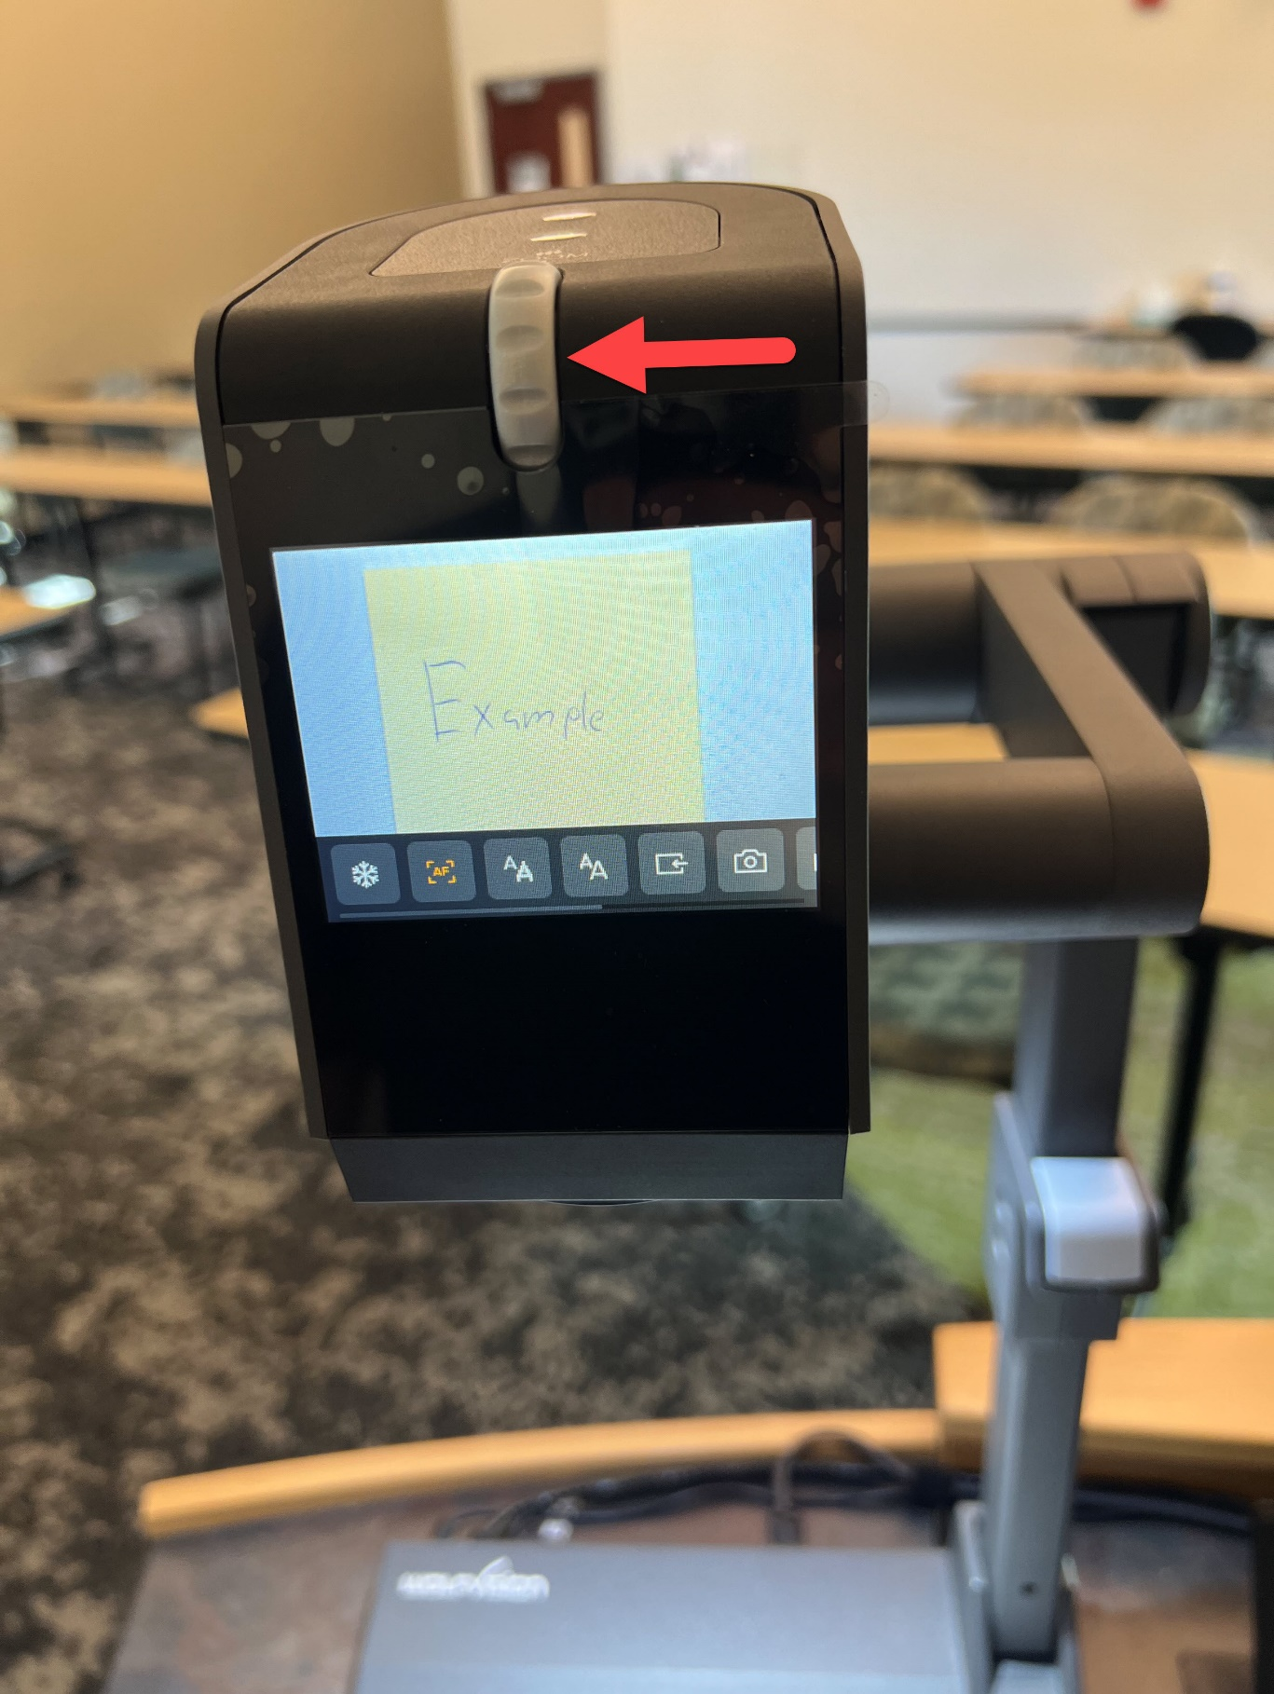

## Powering off the projector

* + Touch the Projector Power icon.

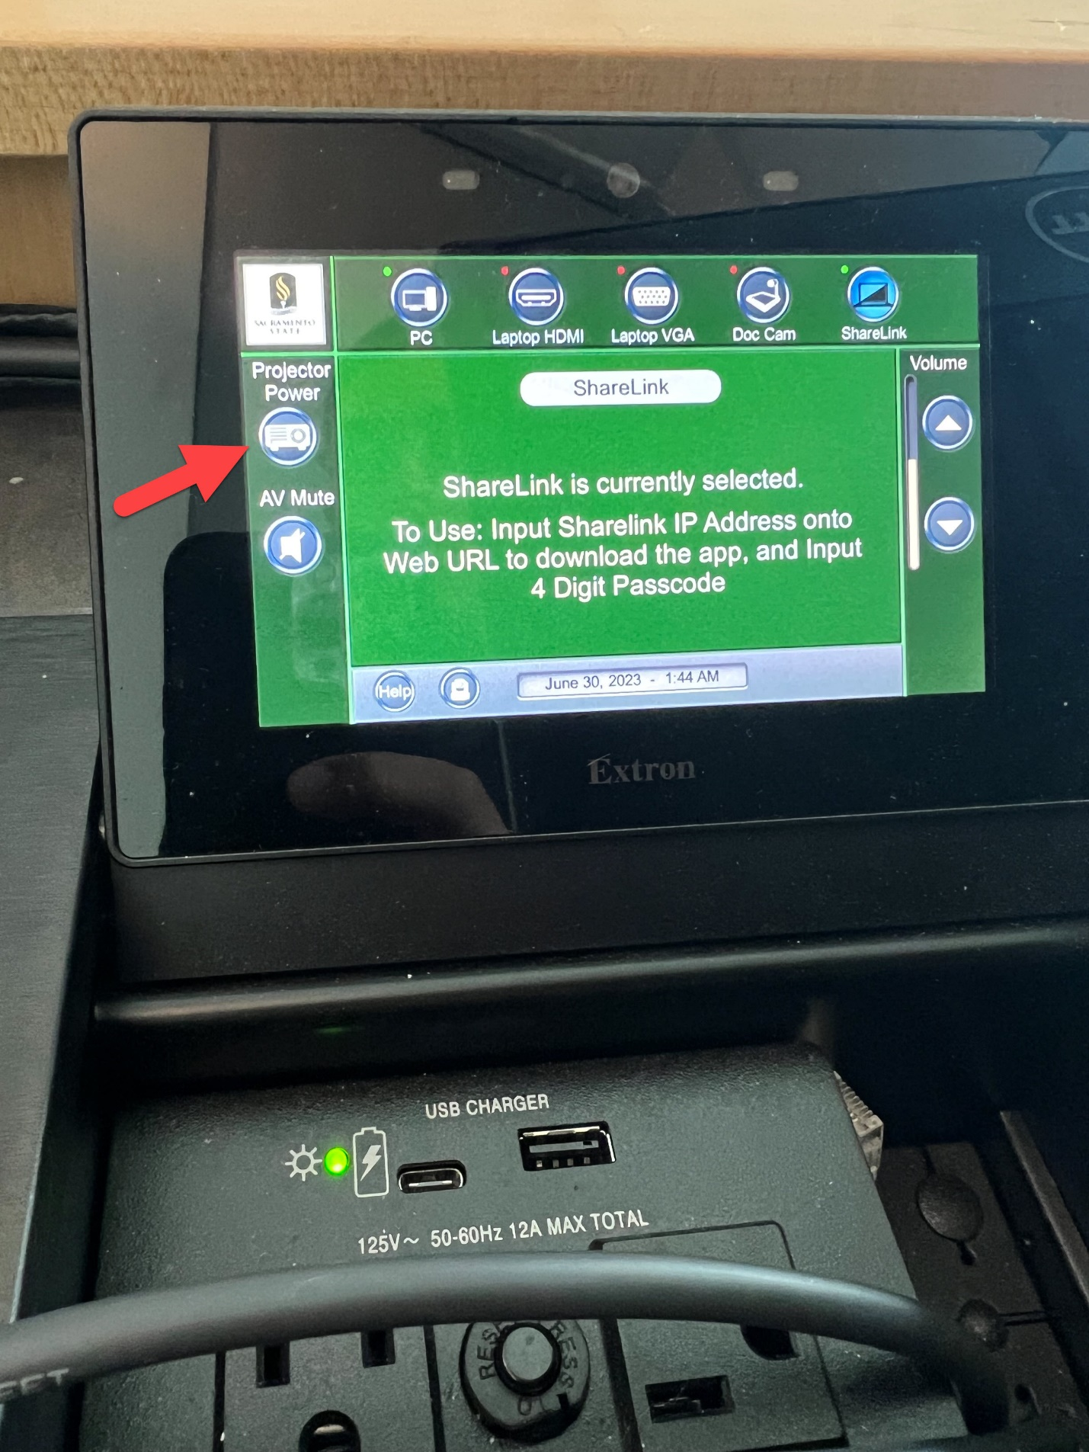

* + Tap the green power button to turn the projector off.

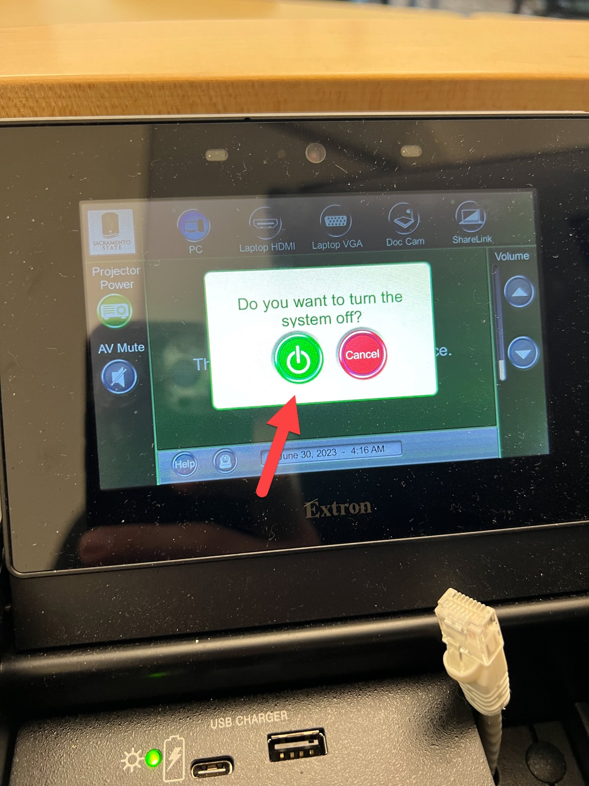

# Modoc Hall

## Modoc Hall Podium

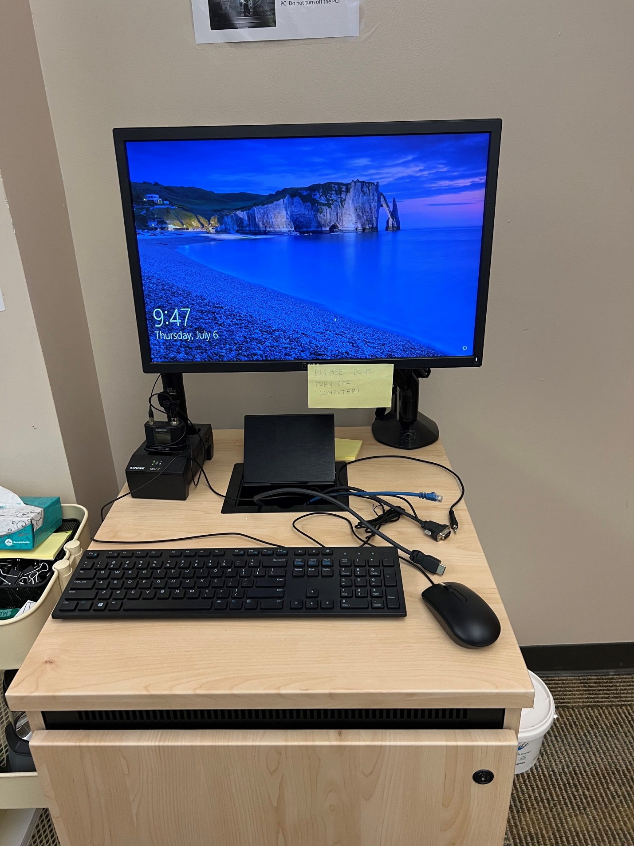

## Modoc Hall Podium Connections

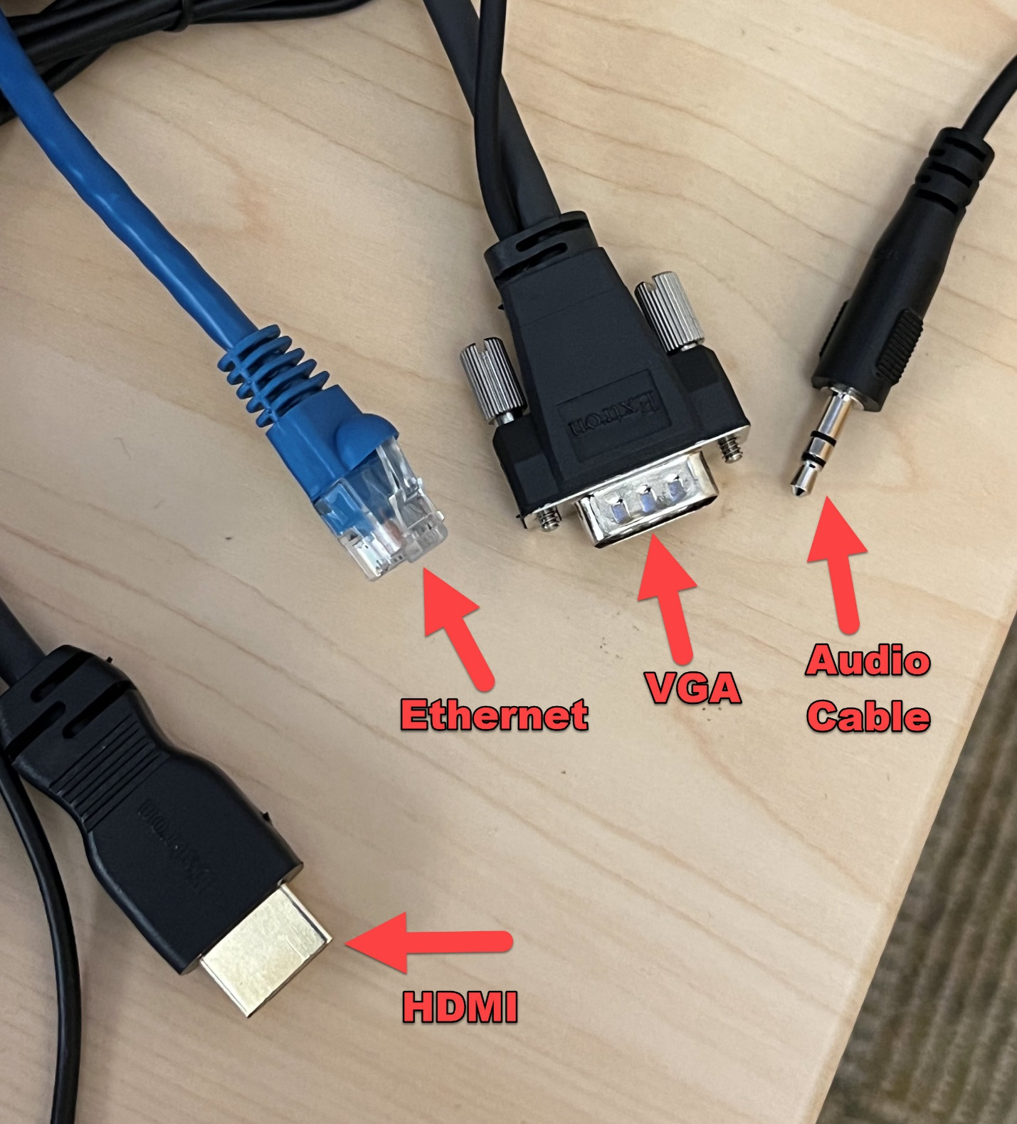

## Powering on the projector

* + Locate the projector control panel and push the ON button.
  + This will power on the projector and lower the projection screen.

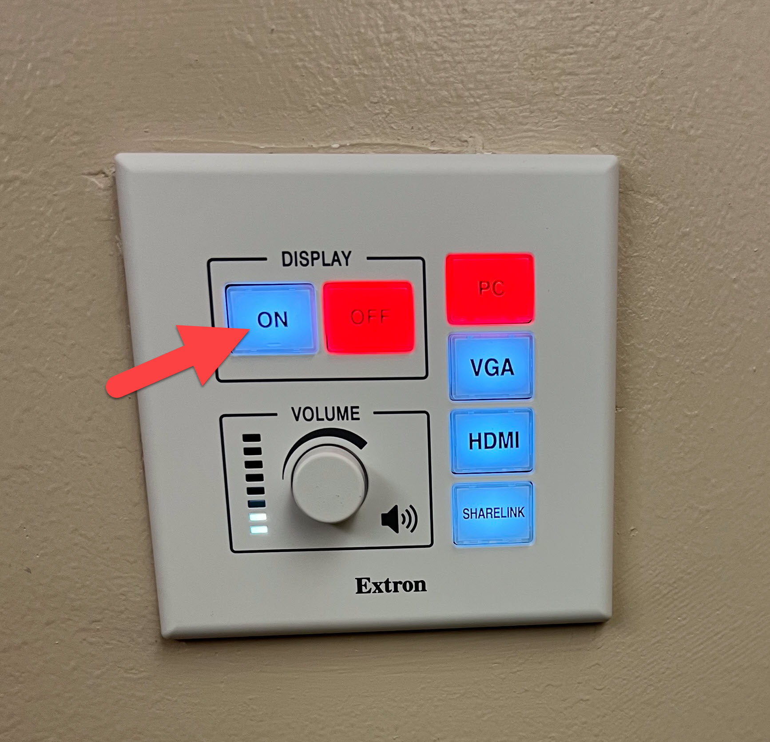

## Connecting your Laptop to the projector via HDMI

* + Connect the podiums HDMI cable into the HDMI port on your computer.



* + Press the HDMI button on the projector’s control panel.

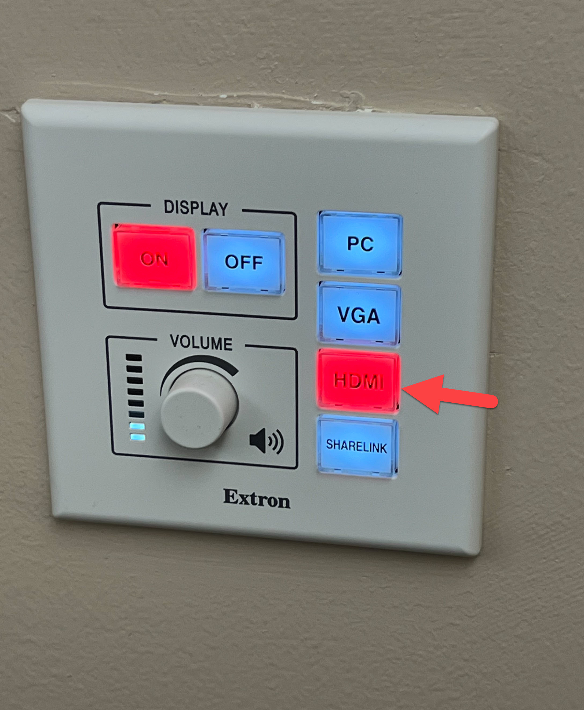

## Connecting your Laptop to the projector via VGA and Audio Cable

* + Connect the podiums VGA cable to the VGA port on your computer.
  + Connect the podiums Audio cable to the audio port on your computer.



* + Press the VGA button on the projector’s control panel.

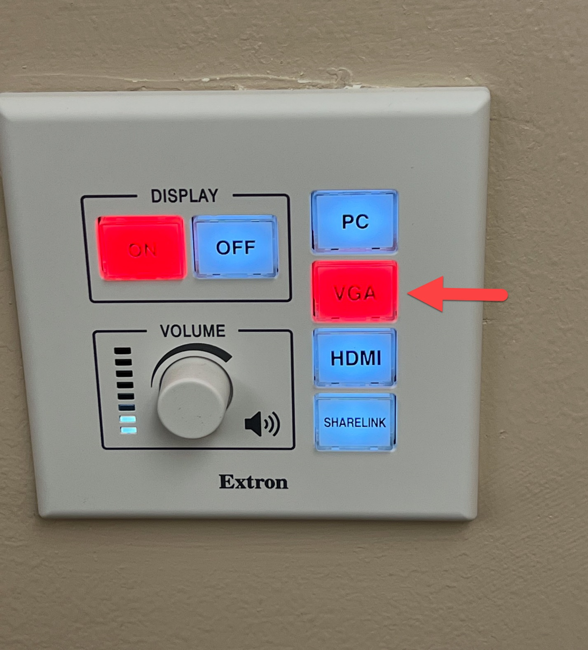

## Connecting your Laptop to the projector via USB-C to VGA adapter

* + Connect the USB-C adapter to a USB-C port on your computer.



* + Connect the VGA cable to the USB-C adapter.



* + Press the VGA button on the projector’s control panel.



## Connecting your Laptop to ShareLink using the ShareLink App

* Press the ShareLink button

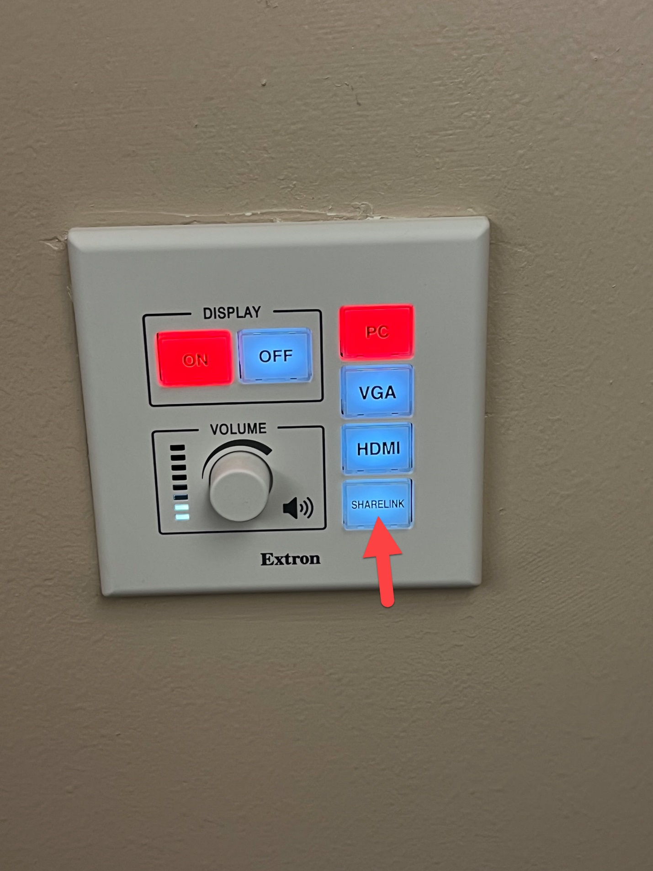

* The projector screen will come down and you will see this screen.
* On the bottom left of the screen you will see your devices IP Address.
* On the bottom right of the screen you will see your devices Code

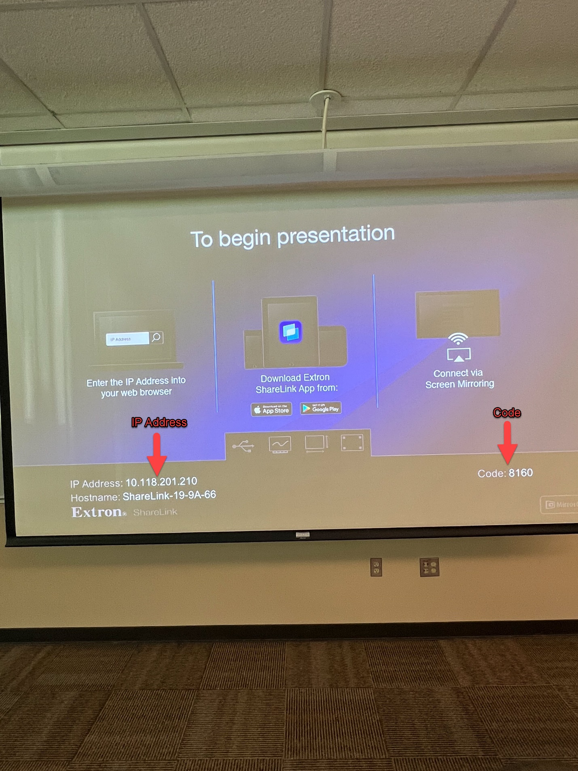

* Open the ShareLink app and type in the IP address.

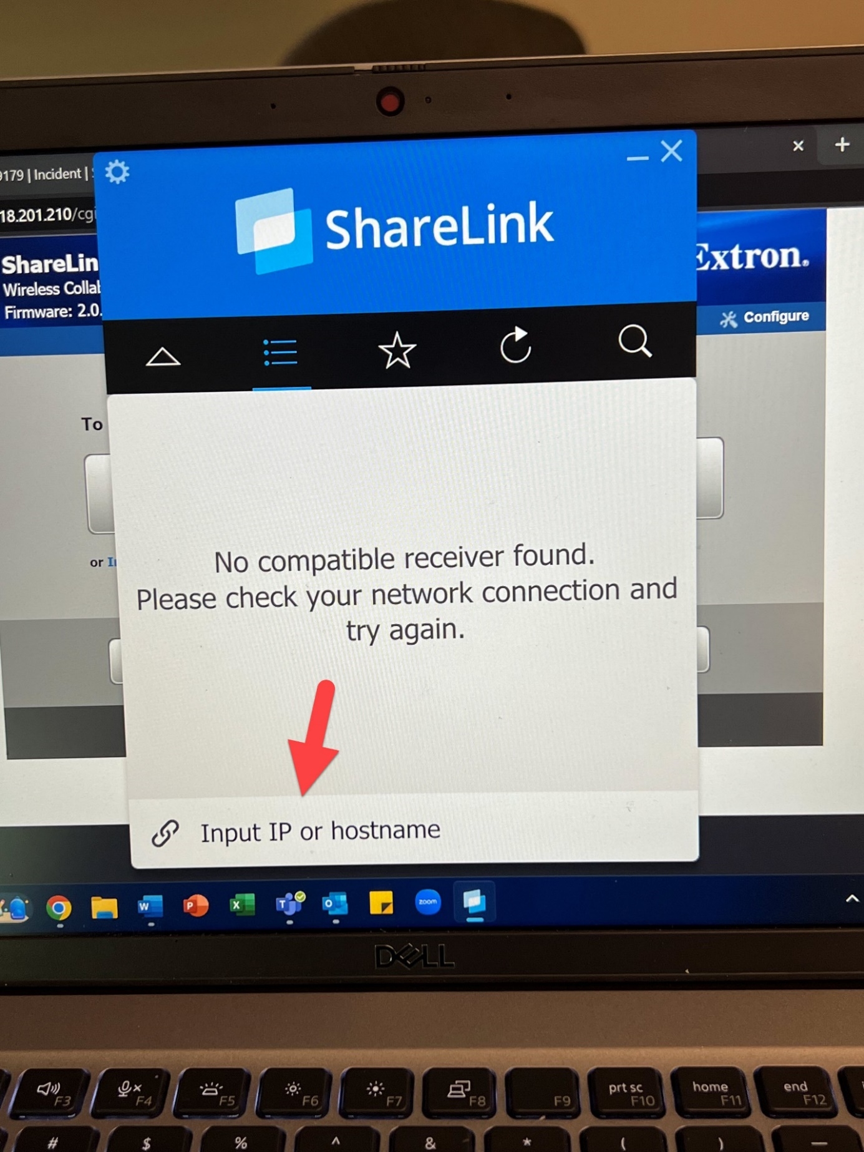

* Enter your devices code.

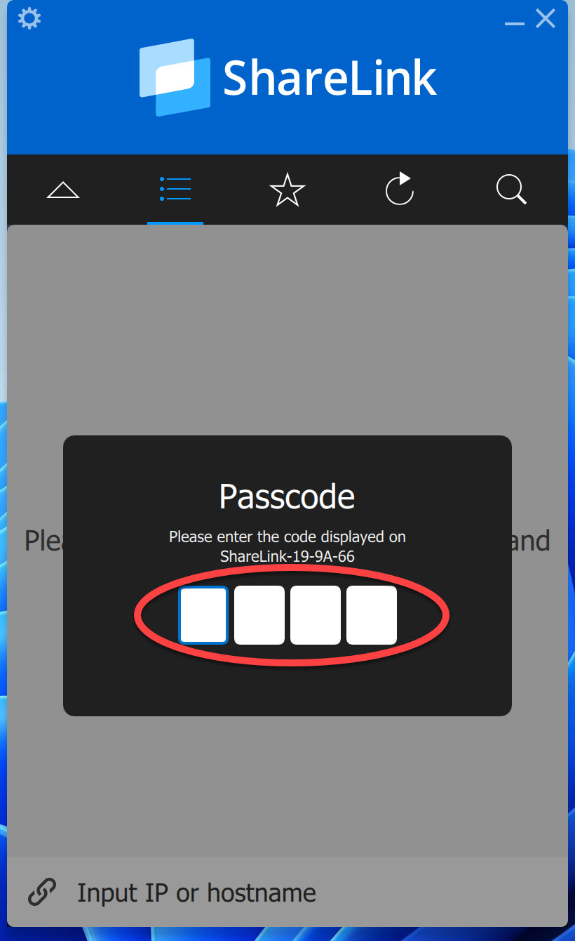

* Your device will now appear on the ShareLink app.
* Click this arrow to close the device list.

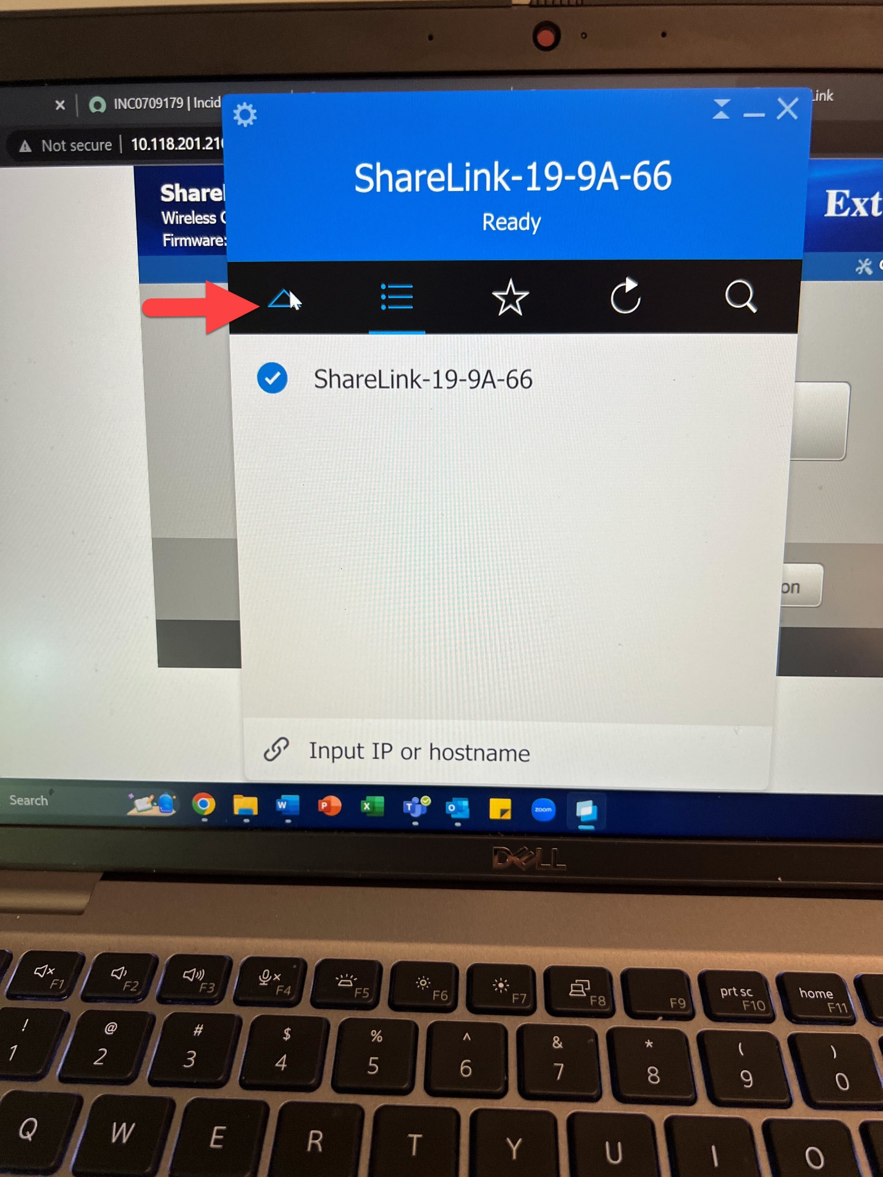

* Click the play button to start mirroring your screen.

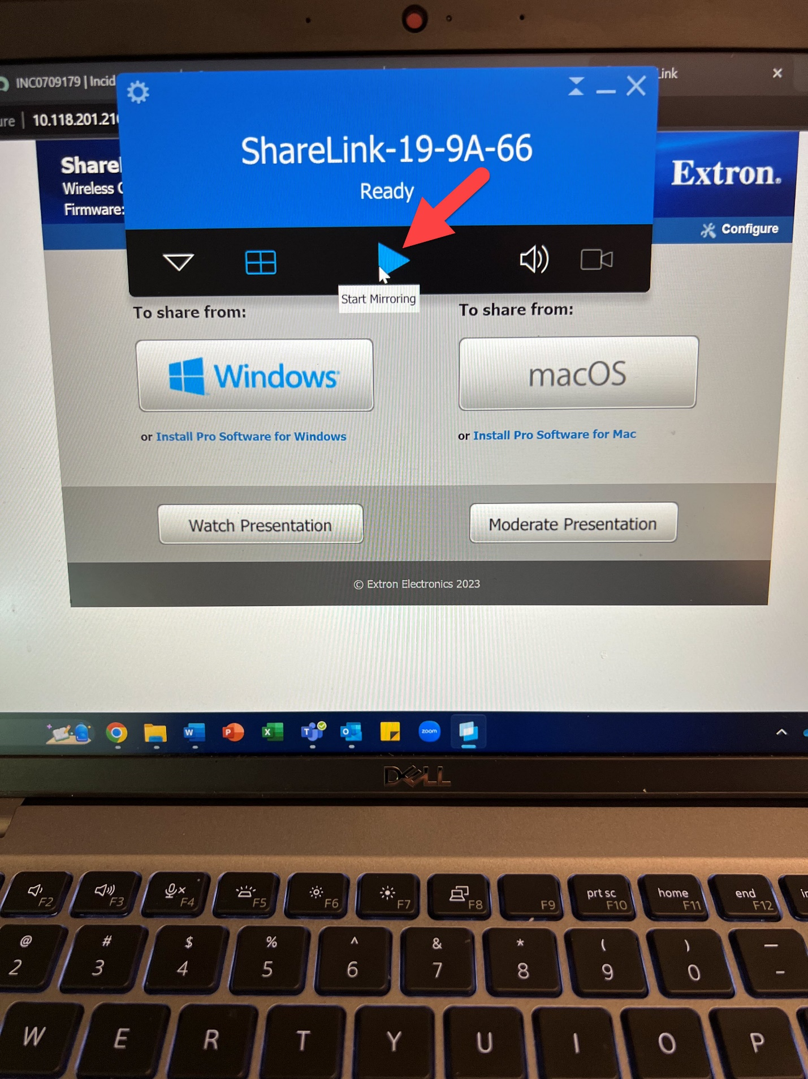

## Handheld Microphone

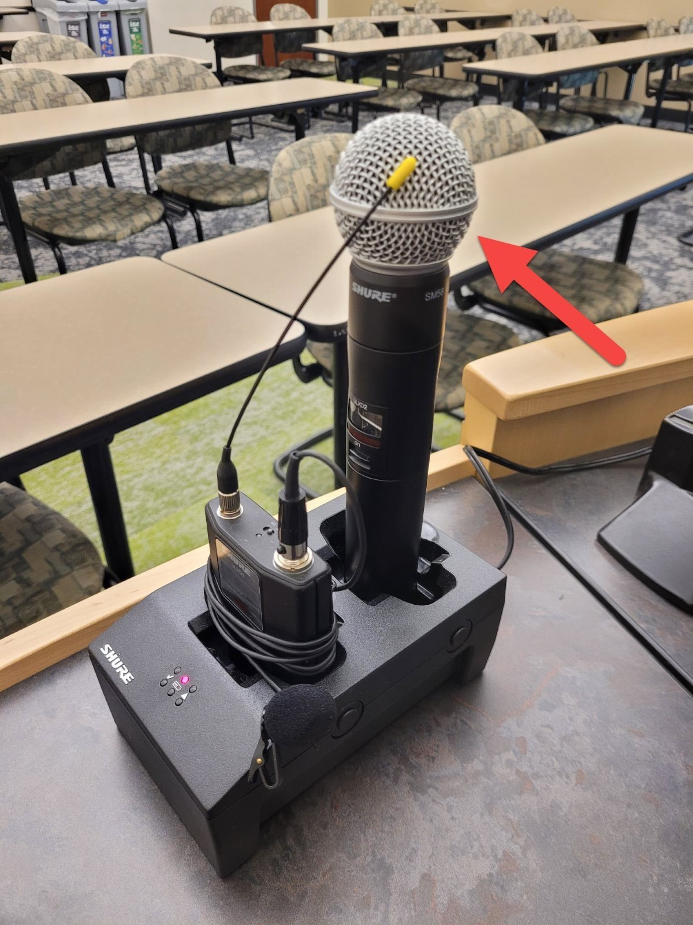

* Pull the handheld microphone out of its dock and move the switch up to the on position.

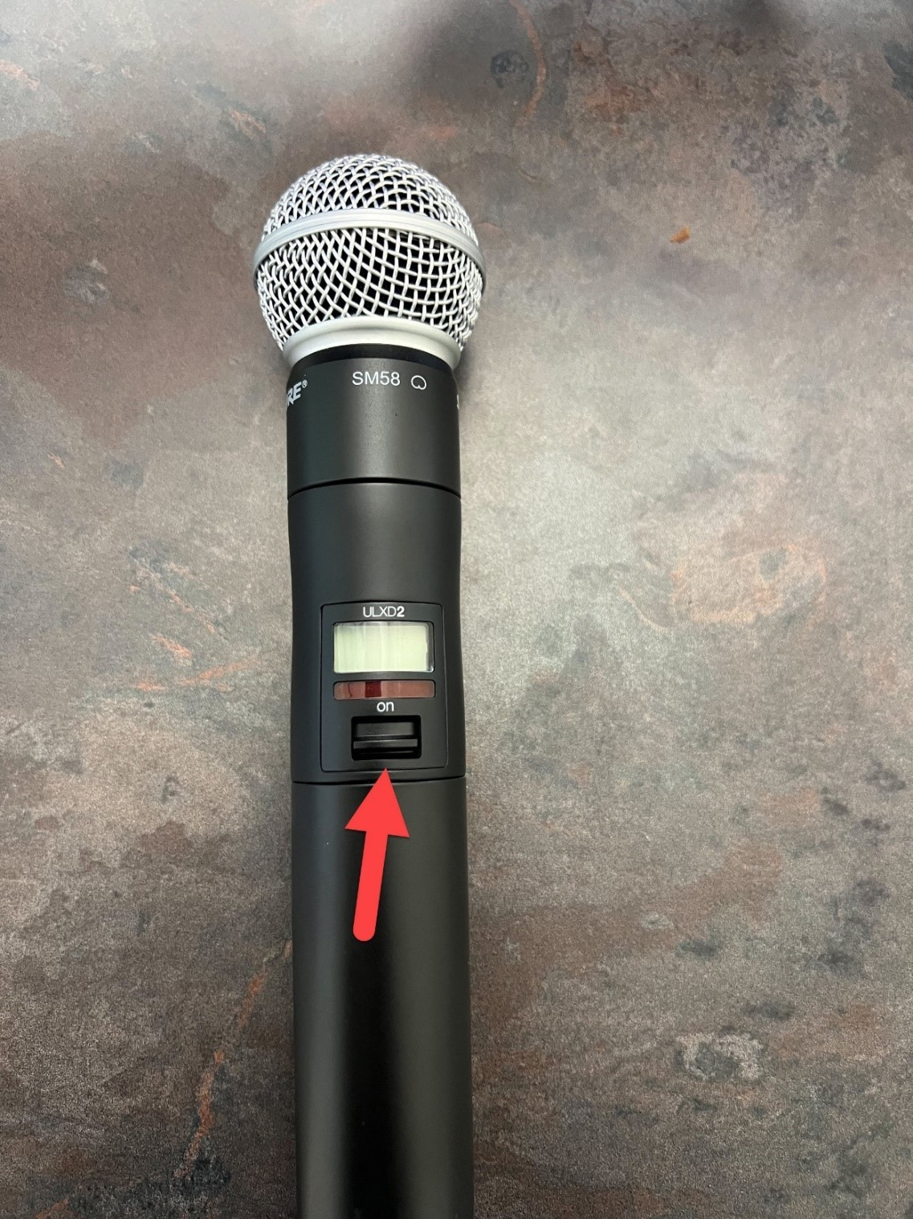

## Lapel Microphone

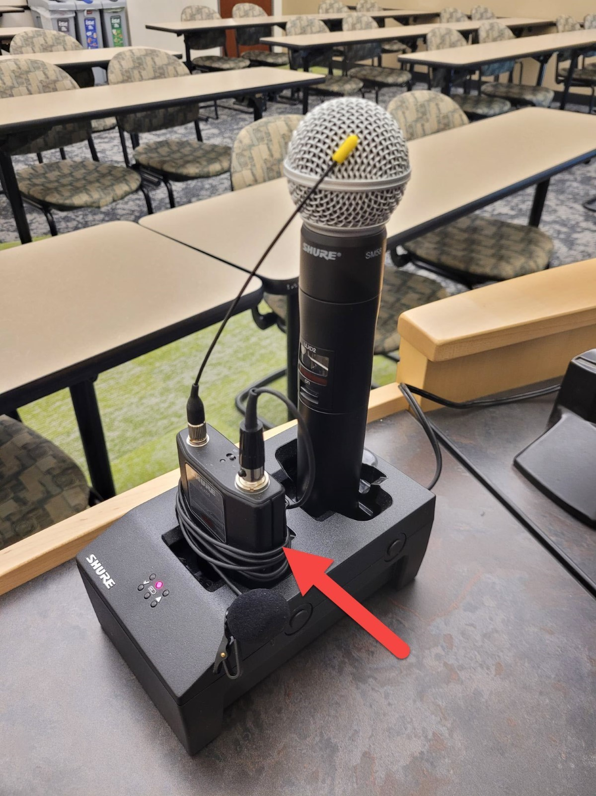

* Pull the Lapel microphone out of its dock.
* Locate the power switch on the top of the microphone and switch it to the on position.

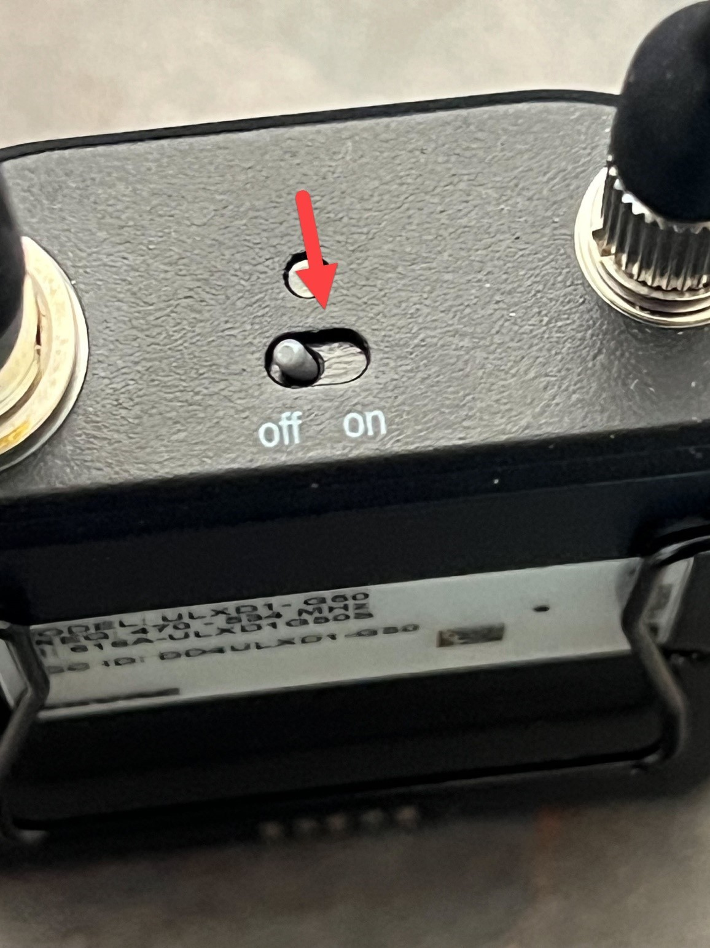

* You will talk into this piece of the microphone.
* This piece also has a clip so you can attach it to your shirt for easy access.

